Welcome back- I’m so glad you are here!

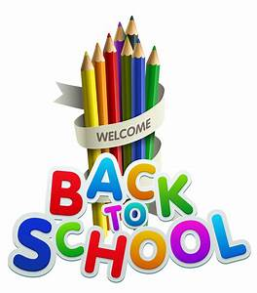

Rang 4, I’ve missed you all!

Rang 3, I’m looking forward to getting to know you all

Parent Information

Teaching and Learning
As a staff, we are very aware that the children have been away from school since March 12th. We appreciate the time and effort that went into Home Learning, and we recognise the challenges that Home Learning presented for all families.

Each child will be a different place in relation to his/her learning, and we wish to assure you that staff will take that into consideration when planning for Teaching and Learning during the 2020/2021 school year.

The Department of Education and Skills has published Curriculum guidelines for us, and we ask you to trust our experience and professional expertise as we work with all the children during the return to school.

Supporting the Learning of Children When They Cannot Attend School
If a child is not able to attend school for an extended period of time, the class teacher (and/or the Special Education Teacher, where relevant) will provide work to support the child’s learning at home and this will be shared with parents/guardians.

The majority of parents have already provided an email address at which the school can contact them to support Home Learning. This will be especially important if the school, or parts of the school have to close due to HSE advice. If you have not already done so, it is advised to please contact stabannonschoolstaff@gmail.com and you will be added to the Contact List for Home Learning.

Things to know:
- Storage boxes will be provided for each individual pupil from third to sixth class. The children will keep all their belongings (books, copies, scissors,glue etc) in their box.
- Children should have a pencil case that they keep in school. This should be left in school at all times. All equipment should be clearly labelled. We ask that you have a separate supply of equipment at home.
- All children should bring a hand towel to school for the drying of hands after handwashing. These towels should be kept in a zip up bag in their school bags.
- Homework will be phased in over the year.
Books we are using:

3rd Class | 4th Class
Ready to Go reader  Ready to Go portfolio | Lift Off! reader  Lift Off! portfolio
Spellings for Me workbook | Spellings for Me workbook
Go with the Flow E | Mrs Murphys handwriting copy (4th class)
Abair Liom E | Abair Liom F
Fuaimeanna agus Focail 3rd Class | Fuaimeanna agus Focail 4th Class
Am don Léamh 3 | Am don Léamh 4
Busy At Maths 3 | Busy At Maths 4
Maths Time 3 | Maths Time 4
Tables Champion 3 | Tables Champion 4
Weaving Wellbeing 4th class
Dabbledoo music subscription
Wordwise 3 & 4
Windows on the World History 3 & 4
Windows on the World Geography 3 & 4
Windows on the World Science 3 & 4
English readers
Irish readers
English dictionary (school edition)

Stationery
88 pg x 6
40 pg x 2
Maths x 1
Project copies x 2
B4 handwriting copy
Whiteboard markers x 2
Glue stick

You will also need:
Pencils , rubber and sharpener (with a cover to hold parings in)
Red pen
Ruler (30cm)
Colouring pencils or twistables

Please ensure all equipment is clearly labelled with your child’s name

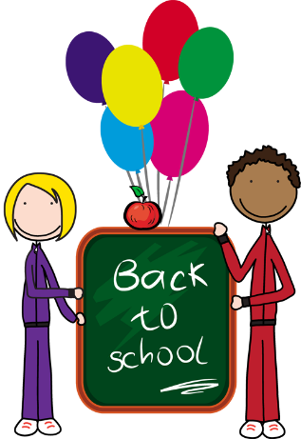
Hi 3rd & 4th Class!
I hope you are all feeling good about coming back to school. I can’t wait to see you all! Things are going to be a little different and I understand some of you might be feeling a little nervous, but it won’t take long to get used to the changes and I know we are going to have lots of happy learning and fun times together in 3rd and 4th class.
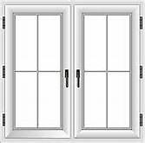
Your class are going to have your own entrance and exit doors from school- you will be using the white double doors at the right of the school.
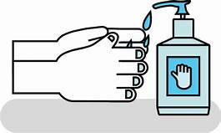
When you come inside the door, there will be hand sanitiser to use and then make your way to our classroom- I will be in there waiting for you each morning! You will be sitting in groups of 4 or 5 – these are called pods. You will have plenty of space at your desk and a box underneath to store all your things.
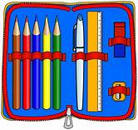
It is important you have your own equipment to use and keep at school. We will try not to share but don’t worry if you forget something- I will have spares! Please don’t bring too much with you and if you have a fancy desk organiser or pencil pot, please keep it for home. There will be no written homework to start but some as the year goes on.
We will be going outside everyday so remember to bring a jacket. You will be playing in zones, like before and you can play with anyone in your classroom. (This is our class bubble) You will need spare shoes and bottoms when you are using the pitch. A zone rota will be stuck in your homework journal and you will know in advance where you are playing each week.
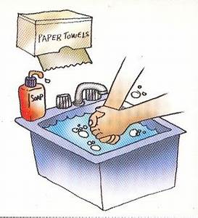
There will be lots of handwashing and hand sanitising throughout the day- before and after you eat, at break-times, at home time and of course after using the toilet.

I am going to wear a mask some of the time but you don’t need to. We are all going to help each other out to get used to everything and I know you will all be brilliant!
See you all soon!

Mrs Duffy

