Welcome back- I’m so glad you are here!

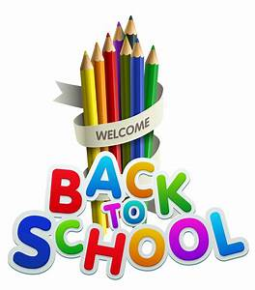

Rang 1 and Rang 2, I’m looking forward to getting to know you all

Parent Information

Teaching and Learning
As a staff, we are very aware that the children have been away from school since March 12th. We appreciate the time and effort that went into Home Learning, and we recognise the challenges that Home Learning presented for all families.

Each child will be a different place in relation to his/her learning, and we wish to assure you that staff will take that into consideration when planning for Teaching and Learning during the 2020/2021 school year.

The Department of Education and Skills has published Curriculum guidelines for us, and we ask you to trust our experience and professional expertise as we work with all the children during the return to school.

Supporting the Learning of Children When They Cannot Attend School
If a child is not able to attend school for an extended period of time, the class teacher (and/or the Special Education Teacher, where relevant) will provide work to support the child’s learning at home and this will be shared with parents/guardians.

The majority of parents have already provided an email address at which the school can contact them to support Home Learning. This will be especially important if the school, or parts of the school have to close due to HSE advice. If you have not already done so, it is advised to please contact stabannonschoolstaff@gmail.com and you will be added to the Contact List for Home Learning.

Things to know:
- Children should have a pencil case that they keep in school. This should be left in school at all times. All equipment should be clearly labelled. We ask that you have a separate supply of equipment at home.
- Homework will be phased in over the year.
- All children should bring a hand towel to school for the drying of hands after handwashing. These towels should be kept in a zip up bag in their school bags.

Books we are using:

1st Class | 2nd Class
Abair Liom D | Abair Liom D
Fuaimeanna agus Focail 2nd Class | Fuaimeanna agus Focail 2nd Class
Busy At Maths 1st class | Busy At Maths 2nd class
Maths challenge 1st | Maths challenge 1st
Weaving Wellbeing | Weaving Wellbeing
Spellings for me 1st  Sounds like phonics C | Spellings for me 2nd  Sounds like phonics D
Go with the flow C | Go with the flow C
Word Wizard 1st | Word Wizard 2nd
1st class readers-  Sleep tight and more  Pirate Pat and more  Jasper save the day | 2nd class readers-  Keep going and more  Clickety-click and more  Jasper goes on holiday
Dabbledoo music subscription

Stationery
Plain day book 32pg x 1
Project copies 15 32pg x 6
Learn to write B2 x 5
Junior sum copy x1
Whiteboard markers x 2
Glue stick
Scrapbook (2nd Class only)

You will also need:
Pencils, rubber and sharpener with lid
Colouring pencils or twistables

Please ensure all equipment is clearly labelled with your child’s name

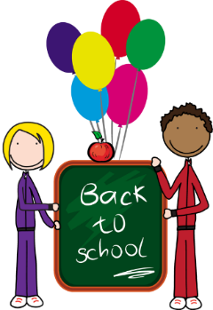
Hi 1st & 2nd Class!
I hope you are all feeling good about coming back to school. I can’t wait to see you all! Things are going to be a little different and I understand some of you might be feeling a little nervous, but it won’t take long to get used to the changes and I know we are going to have lots of happy learning and fun times together in 1st and 2nd class.
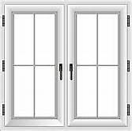
Your class are going to have your own entrance and exit doors from school- you will be using your classroom white door at the back of the school via sloped path. (follow the arrows!)
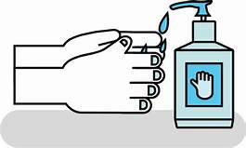
I will be in our room waiting for you each morning. Please use the hand sanitiser on your way in. You will be sitting in groups of 6 or 7 – these are called pods. You will have plenty of space at your desk and a small box to keep your pencils and colours in.
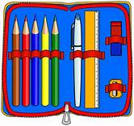
It is important you have your own equipment to use and keep at school. We will try not to share but don’t worry if you forget something- I will have spares! Please don’t bring too much with you and if you have a fancy desk organiser or pencil pot, please keep it for home.
We will be going outside everyday so remember to bring a jacket. You will be playing in zones, like before and you can play with anyone in your classroom. (This is our class bubble) You will need spare shoes and bottoms when you are using the pitch. A zone rota will be stuck in your homework journal and you will know in advance where you are playing each week.
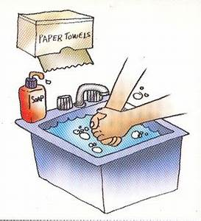
There will be lots of handwashing and hand sanitising throughout the day- before and after you eat, at break-times, at home time and of course after using the toilet.

I am going to wear a mask some of the time but you don’t need to. We are all going to help each other out to get used to everything and I know you will all be brilliant!
See you all soon!

Ms Weldon

