Monday 25th May– Friday 29th of May 6th Class
Daily Activities
- English: Eason’s Spelling Bee - continued
- Practice your tables on: https://www.timestables.com/.
- Maths Starters (Available to download on class section)

English:
- Reading: Keep up the reading at home with your own choice of books
- Activities: Silverfin – Young James Bond (D) Grammar (E) Research (F) Recount Writing
Journal (Ongoing throughout School Closures)

Maths: Busy at Maths: Data: Pg 111, 112
- The Garden Centre – Represent the data in the box on a trend graph
12 PM | 2
1 PM | 6
2 PM | 10
3 PM | 10
4 PM | 6
5 PM | 5
6 PM | 4

The graph on the right is an example of a trend graph.
You need to have a title on your graph.
You need to have labels of your y and x axis.
The x axis is the horizontal line which is labelled Times, and the Y axis is the vertical line that is labelled Number of People.
Draw the red dots first for the number of people attending. Then draw a line to match them all up at the end.
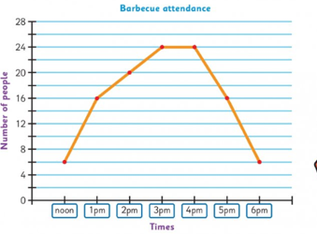

You need to have labels of your y and x axis.
The x axis is the horizontal line which is labelled Friday, Saturday, Sunday and the Y axis is the vertical line that is labelled number of babies
Colour code the classes on your bar chart (for example pink for girls and blue for boys)
Record your information on a tally chart first before you represent the data on the multiple bar chart

Gaeilge:
- Caisleán Gainimh – Read/listen to the story and answer the questions.
- An Samhradh – word mat. (Put 10 words into sentences)
- Cois Trá – Féach ar na pictiúir agus scríobh an scéal.
*Tips
Keep the sentences simple. Use your verb sheet in your irish grammar copy to help you start your sentences.

SESE:
Science
- Draw a diagram of a flower. Label the different parts. Do a little bit of research about the function of each part of the flower.
Include this information on your diagram.

Music: The Orchestra – The String family.
Listen to the instruments in the string family and complete the activity sheet to accompany the lesson. You can listen here on: https://www.youtube.com/watch?v=oEW1plrKG1I
Tips or info

- Good luck using Seesaw this week. It will take time to get used to (for us all).
- I have included some examples about how you could respond to an activity this week in the description boxes, but these are just ideas so that you are aware of different features. You can just complete work in copies as normal and send in pictures of your work via email if not using the app.

Best of luck this week as always, you are doing great work!
If you have any questions about your work you can email me at mssavagestabannon@gmail.com
If you would like to contact Mrs.Stanley, please do so on the following email
mrsstanleystabannon@gmail.com
Have a lovely week, keep in touch! Ms. Savage.

