Monday May 11th – Friday 15th of May 6th Class
Daily Activities
- Spellbound: Revision – Keep practicing your spellings – use the method look, say, cover, write and check method for the tricky ones (resource on class page)
- Fuaimeanna agus Focail: Continue to revise, you can use method above for irish spellings too
- Spelling Challenge Cards (available on class page). You can just choose some of the activities to practice, you do not need to print this resource out.

- Maths Starters (Available to download on class section)
- Tables Champion: Week 30

English:
- Reading: Keep up the reading at home with your own choice of books
- Activities: Great Survivors : (A) A Little Light Thinking (B) Deeper Thinking (C) Vocabulary Work (D) Working with Sounds (Reader Only)
Journal (Ongoing throughout School Closures)
In years to come people will look back and wonder about what it was like to live in this strange time we are in. You are living through history! Keep a journal of what you are getting up to during Covid-19 school closures. You can write, draw, stick in photos or newspaper clippings too. This is your story! You are the Historians of the future!

Maths: Busy at Maths: Data 1: Averages Pg 19, 20
- Calculate the average daily temperature for this week in your area.
- Choose 5 cities in Ireland. Track their weather throughout the week. (Make a graph like the example in the box)
Find the average daily temperature.
What city/cities had temperatures above average/below average?
On the right is an example of a chart to record the temperature
To find the average:
Add up the total amount. Divide the total by the quantity.
For example if we are asked to find the average age of 4 children, aged 7, 6, 9, and 10.
We add all of the ages to find the total amount = 7 + 6 + 9 + 10 = 32
The average age of the children above is 8
2 children are below average (7 and 6) and two children are above average (9 and 10)

Tip* the average always lies somewhere in the middle
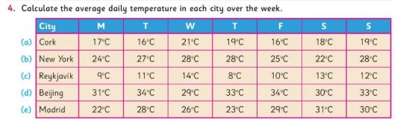
he mi ddle

Gaeilge:
- Word finder: Pick out 10 new words from the story this week and look them up.
- Abair Liom: Tom Crean: Pg 114- 116
- Activities: A, B, C, D
*Tips
- Look up new words before reading the story through
- Use Abair Liom Pg 167 to help with question words
- Part C asks you to summarise the story in paragraphs (or pick out the important points/words from each paragraph – The SS Tera Nova and An Endurance )

Word Box - Verbs
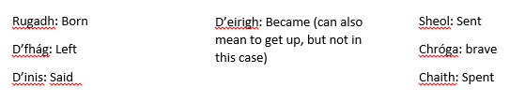

SESE:
History
- The 1916 Rising: Timeline Activity (available to download on class page)

Well-Being: Self- love is so important. You are all wonderfully unique, with different and amazing talents. Each one of you with your own special qualities. It is important to recognise these qualities in yourself. Celebrate all of your unique and wonderful qualities by making a positivity jar. You can also invite others to add to it too (available to download on class page)
Tips or info

- Organise your time as best you can. Try to complete morning activities first to start your routine and break up your work into daily tasks. Try your best as you always do and do what you can.
- I love seeing your work and hearing how you are getting on, so if you haven’t been in touch in a while I’d love to hear from you!

If you are finding English, Gaeilge or Maths difficult, have a look at the S.E.T section of the website and you will find some easier activities. If you are finished early I have uploaded some early finisher activities to complete.
Maths answers will be uploaded on Friday.
If you have any questions about your work you can email me at mssavagestabannon@gmail.com
If you would like to contact Mrs.Stanley, please do so on the following email
mrsstanleystabannon@gmail.com
This week I would like to see your history activity and some snippets of your journal you would like to share.
I am also looking for some photographs for the end of year slideshow. Please note that in sending these pictures on you are giving me permission to use them for the purpose of making the video, and they may also be posted on the school website.
Have a lovely week, keep in touch!
Ms. Savage.

