Monday April 27th – 1st May 5th Class
Daily Activities
- Spellbound: Week 30
- Fuaimeanna agus Focail: Week 30
- Maths Starters (Available to download in class section)
- Tables Champion: Week 28

English:
- Reading: Reader – in school bag/ Keep up the reading at home with your own choice of books
- Activities: Monkey Mayhem: (A) A Little Light Thinking, (B) Deeper Thinking (C) Vocabulary Work (D) Working with Sounds (Portfolio book this week)
Journal (Ongoing throughout School Closures)
In years to come people will look back and wonder about what it was like to live in this strange time we are in. You are living through history! Keep a journal of what you are getting up to during Covid-19 school closures. You can write, draw, stick in photos or newspaper clippings too. This is your story! You are the Historians of the future!

Maths: Topic: Weight
  - Busy at Maths: Weight: Chapter 25: Pg 138 – 139
*Tips
- Remember: Read the question carefully
- Be careful when adding, subtracting, and multiplying decimals – keep decimals one underneath the other
- For long multiplication don’t forget to add the zero on the second line
- Remember the place value of decimals Units . tenths, hundredths, thousandths

- 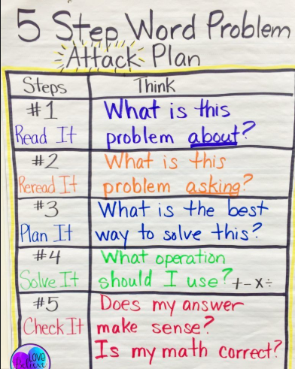 Remember you can use any of the problem solving strategies you have been working on to help you

Gaeilge:
- An Rinc Scátála Oighir – Activity Worksheet (Available to download on class page)
- Gaeilge Neamhfhoirmiúil: Nominate a member of your household to ask you about the weather each day. See what phrases you can remember from last week. Try to impress with all of your fantastic vocabulary.
*Tips
- Keep your sentences simple
- Follow the same layout of the poster in your book
- Use similar phrases and adapt them to suit your topic

SESE:
Geography
- Lakes of Ireland- Labelling Activity. (if you are printing activity pages out you could cut out the finished map and add it to your Geography copy. If not simply write the answers into your copy.

Music
Tchaikovsky’s Swan Lake. Learn about Tchaikovsky’s Swan Lake, watch the ballet dancers perform and respond to the music through writing and art. Information and activity pages available to download on class page.
Tips or info

- Organise your time as best you can. Try to complete morning activities first to start your routine and break up your work into daily tasks. Try your best as you always do and do what you can.

If you are finding English, Gaeilge or Maths difficult, have a look at the S.E.T section of the website and you will find some easier activities.
Maths answers will be uploaded on Friday.
If you have any questions about your work you can email me at mssavagestabannon@gmail.com
I’d love to see your Nuacht this week, so if you like, you can take a photograph of it and send it to the above address. Also, if anyone completed the Recipe activity you can send it on and I will share them on the website.

