4th Class Maths Answers Monday 27th – Friday 1st
Maths Time 4 Week 30
Mon | Tues | Wed | Thurs | Fri
1. 180  2.9 9/10 0  3. 10  4. 9:57  5. 9217  6. 450  7. 8820  8. 3/4  9. 21  10. 0.9  11. €0.90  12. 10.0, 10.2, 10.4  13. True  14. 2000  15. 45 | 1. 2.21  2. 5  3. 443  4. 592  5. 0  6. 1404  7. 6540  8. 56  9. >  10. 8 hrs 105 mins = 9 hrs 45 mins  11. 4  12. 5650  13. €10.50  14. 28  15. Answers will vary | 1. 10  2. 4/10 0  3. 5.2  4. 5 each  5. 3.5  6. 350  7. 6  8. 1/6  9. 108  10. 750  11. More  12. No  13. 0.3  14. 600 g  15. 8690 | 1. 8.5 or 8 1/2  2. €16.20  3. 6.33  4. 66  5. 3  6. 3 hrs 30 mins  7. 6100  8. 0.85  9. 1025  10. 10.06  11. 96 r 6  12. 1250  13. 6  14. 12  15. 24 | 1. 3.24  2. 90  3. 472  4. 6.8  5. 2.25  6. 8  7. 2030  8. 2/3  9. €72.79  10. 1.18  11. 64  12. 7.5  13. 3000  14. 33  15. True

Action Maths : Capacity
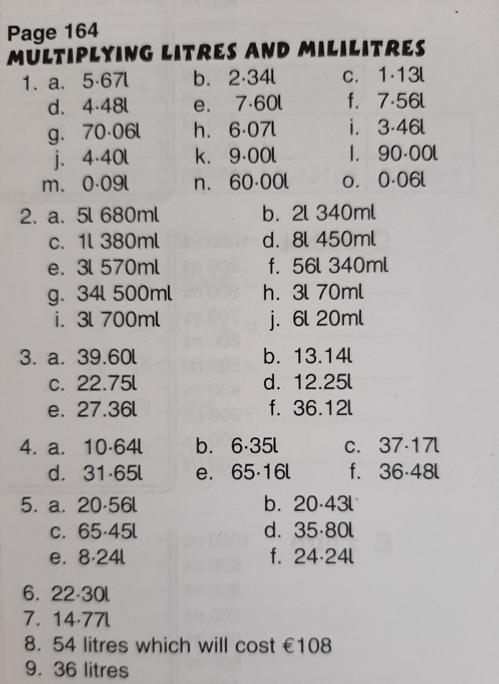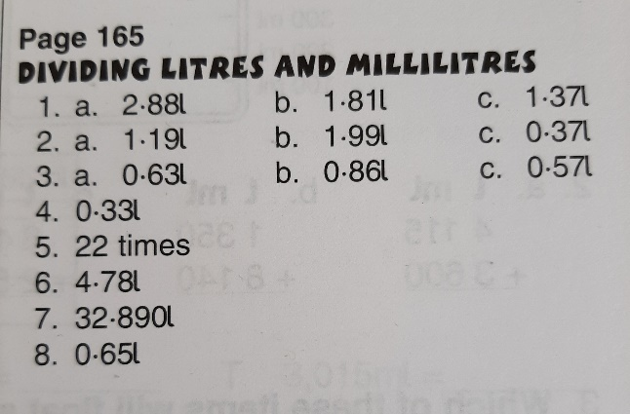
Action Maths : Chance
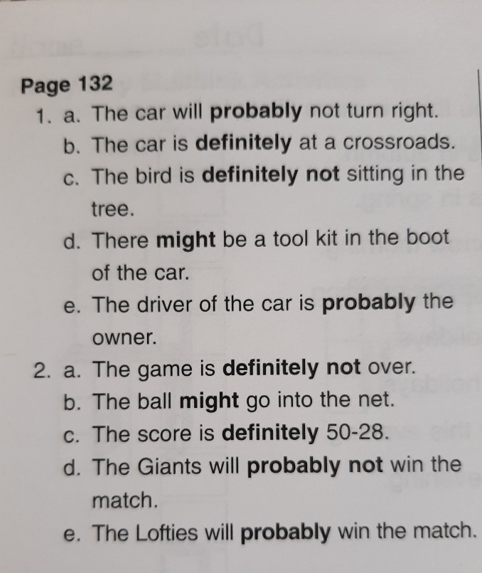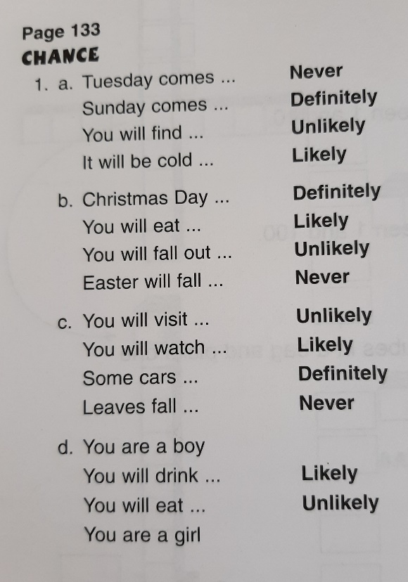

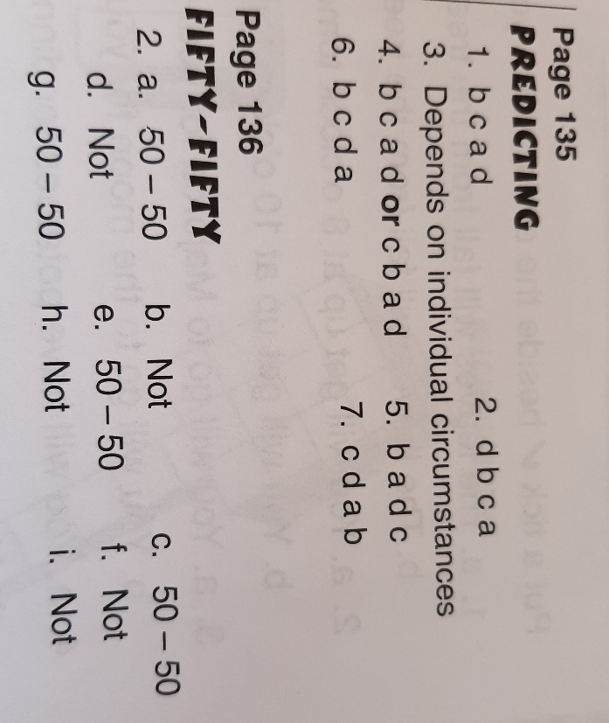

Tables Champion
