Maths Answers Monday 27th – Friday 1st
3rd Class
Maths Time Week 30
Monday | Tuesday | Wednesday | Thursday | Friday
1.20  2.20  3.5  4.€3.50  5.8  6.200  7.48  8.6  9. Teacher check  10.1 hr 5 mins  11.700  12.2 r 2  13.9  14.>  15.7 | 1.428  2.70  3.9:45  4.€7.57  5.7 m 65 cm  6.300  7. Teacher check  8.3  9. 9/10  10.Hexagon  11.670  12.15.1, 11.5, 5.1, 5.0, 0.5  13.43  14.>  15.1 6/10 | 1.40  2.25  3.€2.69  4.520  5.101, 201, 301, 401, 501  6.500  7.74  8.6  9. 2/8 or 1/4  10.3  11.7 in 72.6  12.56  13.11  14.>  15.10 | 1.8 hundreds 6 tens 2 units  2.30  3.2  4.July  5.110  6.400  7.136  8.8  9. 2/10  10.756, 576, 567  11.567  12.4 r 2  13.40  14.10  15.< | 1.70  2.30  3.506  4.400  5.150, 250, 350, 650, 850  6.600  7.75  8.8  9. 4/8 or 1/2  10.12  11.909  12.3 r 3  13.6  14.5 7/1 0  15.7

Action Maths 3: Capacity
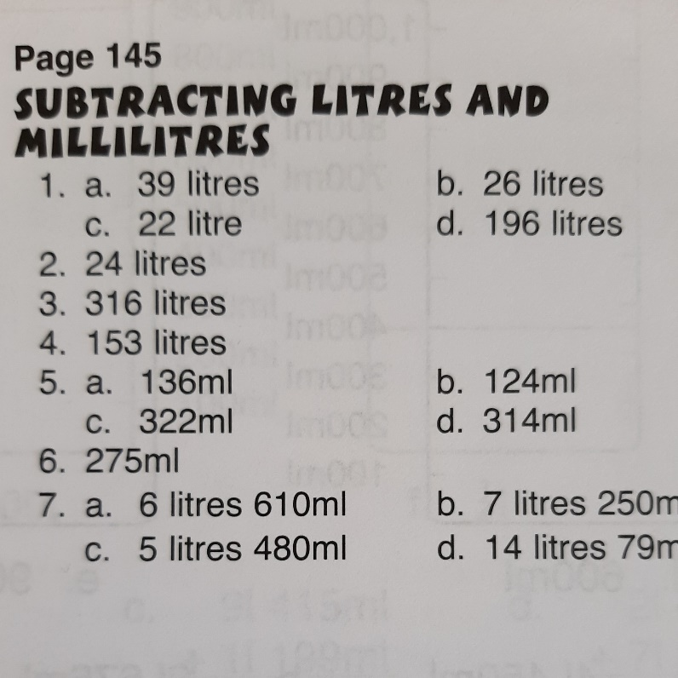

Action Maths : Chance p151 - 153
Your answers will vary here as you are all different. You can email me a photo of your completed work and I will check over it. I’d really like to see your what happened next pictures

Tables Champion 3 Week 27
