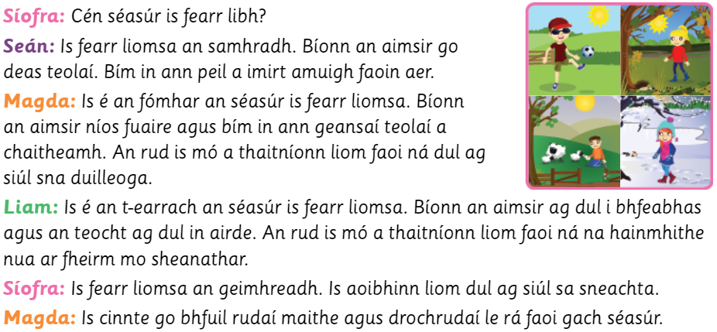

Cén séasúr is fearr libh? (What is your favourite season?)
Note the two phrases for giving the same opinion
Is fearr liomsa an samhradh. (My favourite season is summer)
Is é an fómhar an séasúr is fear liomsa. (The autumn is my favourite season)
Is é an t-earrach an séasúr is fearr liomsa. (My favourite season is spring)
Is fearr liomsa an geimhreadh. (The winter is my favourite season)

Word box
Go deas teolaí: nice and warm
Níos fuaire: colder
Ag dul i bhfeabhas: getting better
Teocht ag dul in airde: temperature rising
All of the children above had their own favourite season. They used some of the phrases above.

Activity One:
What is your favourite season? Answer the question using the above phrases and vocab to help you. Also add a reason as to why – for example Seán said that he likes the summer because it is nice and warm and he can play football outside. (There are lots of good phrases in part E to help you with this part)

Activity Two:
.
Liam used the following phrase when he was explaining why he liked the spring. It is a good phrase to use and can be used to give your opinion on anything. For example:
Is fearr liom Mata. An rud is mó a thaitníonn liom faoi ná ag comhaireamh: Maths is my favourite. The thing I like the most about it is counting.
Use this phrase in 5 sentences for a little bit of practice!

Activity Three:
Complete activity E in your workbook, if you are now familiar with the phrases.

Activity Four:
Na Ceithre Shéasúr – draw how a tree would look in each of the four seasons

