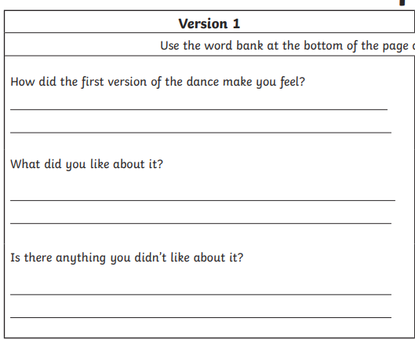

Now listen to the music without looking at the video, close your eyes
What do you picture?
Play it again and draw what you imagine when listening to the music.

