Scoil san Nioclás scoop
Blast off into june!
Q: How did the astronaut serve dinner in outer space?  A: On a flying saucer!  3,2,1…Lift Off!  Nasa and SpaceX have teamed up to launch a spacecraft carrying two astronauts into space. This will be the first time since 2011 that a ship carrying people into space will blast off from American soil. The Demo-2 mission will have lift off from the Kennedy Space Centre in Florida, on 30 May. Since 2011 Nasa has relied on Russia, Japan and Europe to help transport astronauts and supplies to and from space.  SpaceX is a private space company owned by billionaire Elon Musk, which wants to make carrying stuff into space cheaper - and one day wants to run space tourism trips into orbit and the Moon. Elon Musk is an inventor who owns the company Tesla as well as Space X, and he made a lot of money by selling the online payment service PayPal to eBay.  The Demo-2’s goal is to transport two astronauts, Robert Behnken and Douglas Hurley to the International Space Station. They are two of NASA’s most experienced astronauts. Robert and Douglas have both been to space twice, and are even both married to astronauts! They are wearing some pretty cool new spacesuits which were custom designed by Jose Fernandez, a costume designer who worked on the Batman, X-Men and Thor movies. Their main mission is simply to check that the new spaceship works, and is capable of transporting astronauts safely into space.  If the mission is successful, it will help researchers to gather important information for future exploration, like the upcoming Artemis mission, which aims to put the first woman and next man on the Moon by 2024.  You can watch the launch on YouTube at https://www.youtube.com/watch?v=nA9UZF-SZoQ  Get your thinking caps on… It’s Quiz Time!  Competition Time  Here is another competitions you might like to enter:  Creativity Art Competition  ‘Freedom in a Time of Constraint’  For more details check out  https://www.artmaterials.ie/art-competition/ | 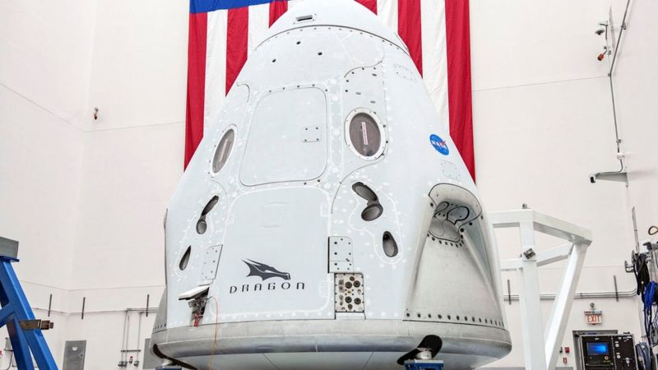  SpaceX’s Crew Dragon spacecraft, using a Falcon 9 rocket for lift off  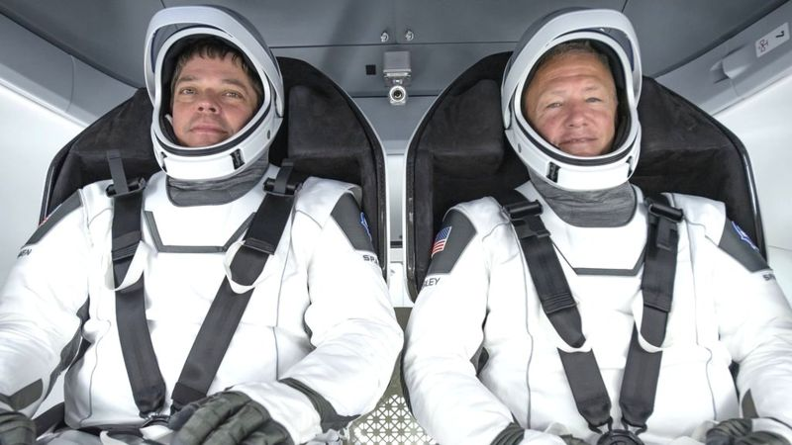  Bob and Doug have both flown to space twice already - so they're pretty experienced!  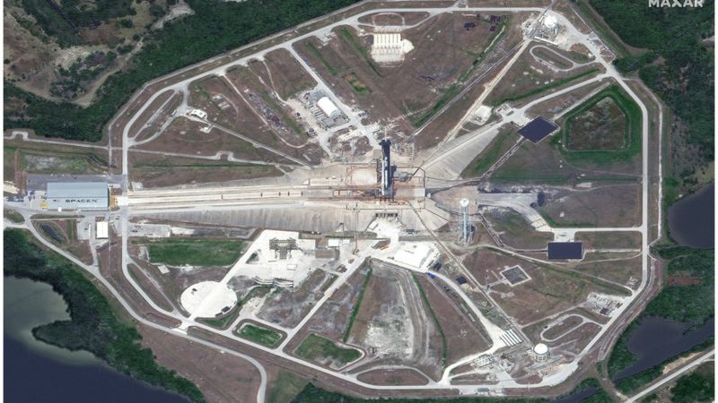  The super high-resolution WorldView-3 satellite images of Kennedy's Pad 39A  Hidden Word  - What country was the composer Mozart born in?  - What colour is an aircraft’s blackbox?  - What is the world’s saltiest sea? (Clue: It has a morbid name)  - Which continent gets the least amount of rain?  - The name of which Irish county is the same as a five lined poem?  - Who was the first person to reach the South Pole?  - Redback and Funnelweb are what kind of creature?  - Complete the proverb…A stitch in time saves ….what?  - How many colours in a rainbow?  - In what year did World War Two end?  Answers from last week – 1. Octopus 2. 206 3. Blue 4. Antarctica 5. Carlow 6.Hong Kong 7. Five 8.Scar 9. Antrim 10.Fionn mac Cumhaill  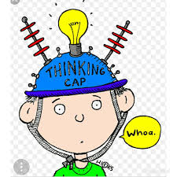
What are your friends doing?
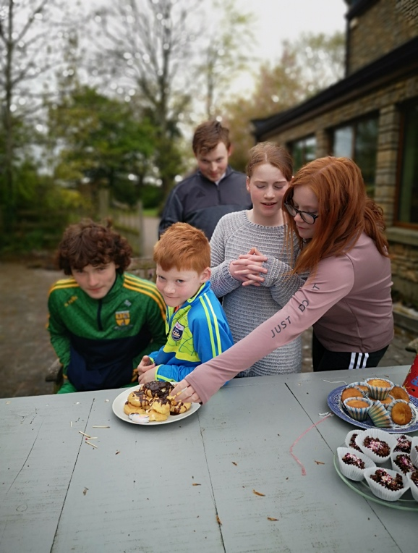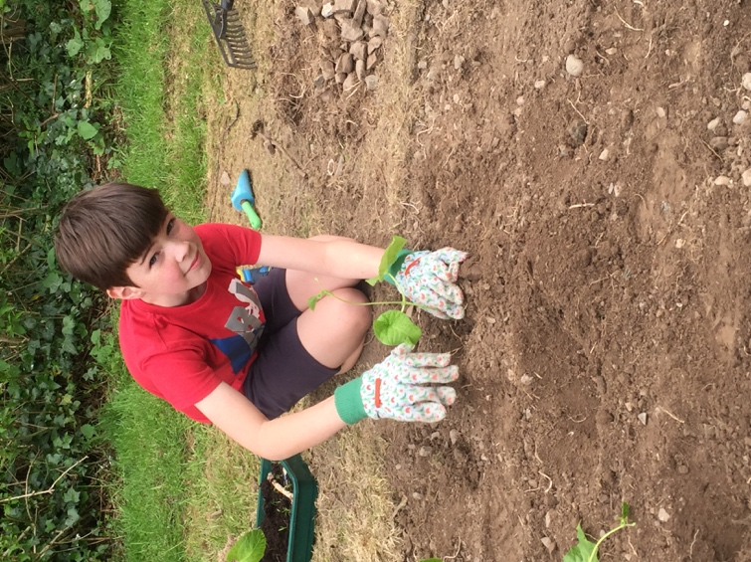
Bubbles are fun! | Planting in the garden  Picnic in the sun!
`
Get your thinking caps on… It’s Quiz Time!

