Monday April 20^{7h} – Friday 1st May Senior Infants
Aistear
Play is a very important part of our day. We can learn a lot through play. Our theme this month is The Zoo. Have you any books about wild animals or the zoo that you could read? I have added a new book about a visit to the zoo for you to look at this week if you want.. Dublin Zoo are doing Safari Watch videos on their YouTube channel. Why not take a look at what animals you can see. How is the zoo you built going? Could you add more animals to it? You could draw or make them and then add them in. Why don’t you brin your family/teddies/dolls on a trip to your zoo. Tell them about some the animals there. What one is your favourtie?

English:
- Phonics/ Tricky Words: Revising all sounds (See Hints and Tips). How many different words can you write? Have a competition with yourself every day and see if you can beat your score. Revise all Tricky words too.
- Reading:
Keep reading over books sent home and any other books at home.
Follow this link to Starfall website (I’m Reading-Ficton and Non Ficton)you can try reading these 4 books: Dragon goes to the Farm; It’s Earth Day, Dear Dragon; Pumpkin, Pumpkin; A house in a tree
https://www.starfall.com/h/ir-fnf/?sn=im-reading
Reading to your child is also very important.

- Writing: You can revise all letters on Go With the Flow website (see Hints and Tips).
Can your write 4/5 sentences about this picture.
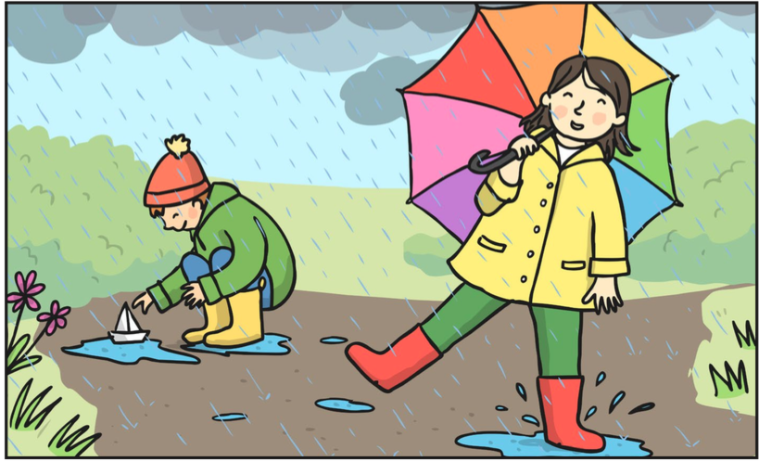
Here are some words that might help you: rain, cloud, umbrella, puddle, splash, boat, float

Maths: (See Hints and Tips for games and activities)
- Pages 105-109: Money

Gaeilge:
Go to the Folens Website https://www.folensonline.ie/home/library/programmes/abair-liom-junior-infants/resources/

-Abair Liom A-Resources-Lesson 26 An Teach: Thuas Staighre
- Click on the póstaer. Listen to the scéal and the dán and amhrán too. Play the games. There is also a cluiche meaitseála on the main screen.
- Draw a picture of your teach. Draw you and your family in different rooms. Can you label the different rooms. (vocab cards attached) or write a sentence about your house.
- Tá mé/mamaí/daidí sa chistin/ghairdín/seomra suite/seomra folctha/seomra codlata.

Tip: To access the Folens Online website follow these instructions:
- Go to FolensOnline.ie and click register
- Select Teacher
- Fill in a username, email and password
- For Roll Number use the code: Prim20

SESE:
Floating and Sinking:
Did you know some things float and some things sink? Can you think of some things that you use maybe in the bath that float or sink? Can you think of anything that floats or sinks when you are washing up after dinner? With mammy or daddys permission set up a basin of water in the garden. Why don’t you see if any of your zoo animals float or sink (plastic ones), if you have any.
Can you see if the following things float or sink. Split a page in two. Draw pictures of the things that floated on one side and the things that sank on the other (or you can use the page attached). Can you write a sentence that explains what floated and what didn’t.
- Teaspoon
- Apple or another piece of fruit
- Lego block
- Ruler
- Coin money
- Pencil
Project: Keep working on your project. Remember you can add in anything you want.

