Senior Infants Maths Answers Week 20th April

Page | Answer
100 | 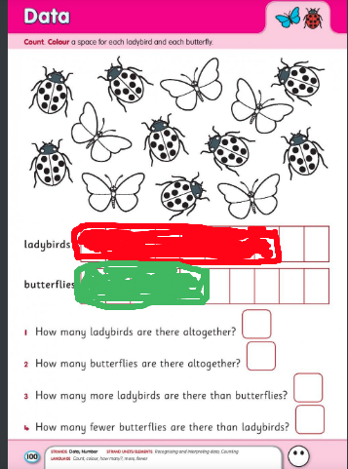  - 8  - 5  - 3  - 3
101 | 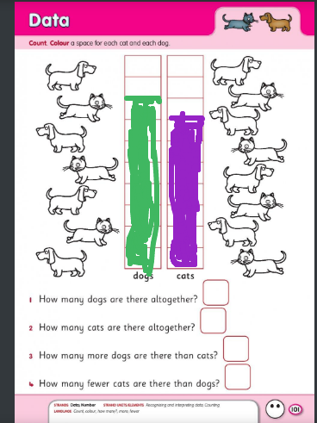  - 8  - 7  - 1  - 1
102 | - 8 is more than 7 by 1  - 7 is more than 5 by 2  - 9 is more than 8 by 1  - 8 is more than 6 by 2  - 10 is more than 7 by 3
103 | - 6 is less than 7 by 1  - 4 is less than 6 by 2  - 7 is less than 10 by 3  - 6 is less than 9 by 3  - 3 is less than 8 by 5
104 | 