Senior Infants Maths Answers

Page | Answer
87 | Colour in all animals and trace correct numeral.  Pigs 10, ducks 9, cats 8, elephants 9, cows 10, sheep 10, horses 8
88 | Colour in and write the correct numeral (see rhyme formation posters). Strawberries 9, balls 8, leaves 10, chicks 7, peanuts 5, pencils 9, bananas 10, apples 6, oranges 8, pears 7
89 | Trace and colour in the correct number of objects: cups 6, bowls 8, teapots 10, kettles 7, glasses 9, spoons 10
90 | Write the story of 10 with all numerals formed correctly.  10+0=10  9+1=10  8+2=10  7+3=10  6+4=10  5+5=10  4+6=10  3+7=10  2+8=10  9+1=10  0+10=10
91 | 5+5=10 circles  5+4=9 triangles  3+7=10 squares  4+5=9 rectangles  2+6=8 cylinders  4+6=10 spheres  1+9=10 cubes  5+2=7 cuboids
92 | Buttons 6+4=10  Stars 5+4=9  Eggs 7+3=10  Balls 4+6=10  Strawberries 5+3=8  Bananas 2+8=10  Cookies 5+5=10  Oranges 3+7=10
94 | Triangles 2+3+4=9  Cubes 4+2+3=9  Cubes 4+2+1=7  Balls 3+2+5=10  Cylinders 5+2+1=8  Cylinders 3+3+4=10  Cuboids 5+3+1=9
95 | A 10  B 9  C 8  D 9  E 7  F 3+4+3=10  G 4+2+3=9  H 5+4+1=10  I 6+1+3=10  J 2+4+4=10
96 | A 7  B 8  C 10  D 9  E 8  F 9  G 9  H 10  I 10  J 10  K 9  L 9
97 | 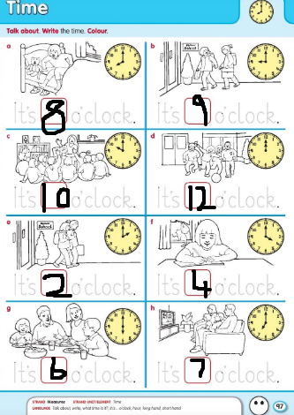Trace and write in the correct time.
98 | 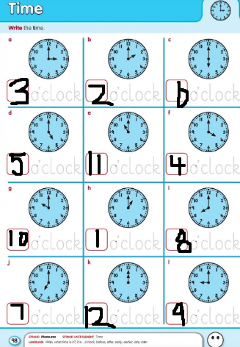Trace and ensure correct numeral formation.
99 | 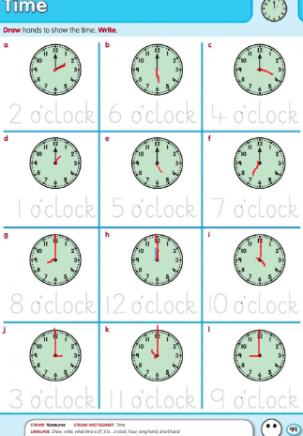  Trace the time and draw the hands, with a difference between big and little.

