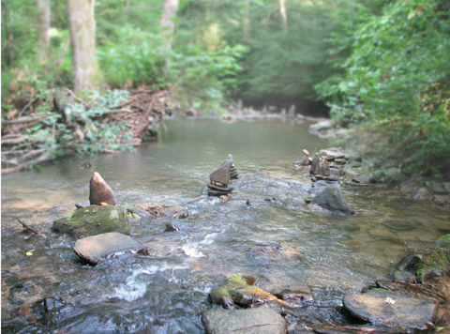
Jumping Frog
Find a backdrop like this one
Animate a frog sprite to jump from stone to stone.
Animate a fly to whizz around in the air.
Challenge! Every time the frog lands on a stone it says “ribbit!”
___________________________________________________________
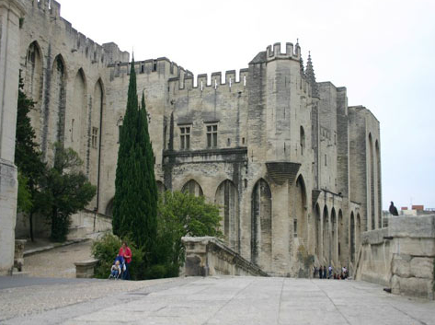
Dragon and Princess
Find a backdrop showing a castle…
Animate a princess to run around in front of the castle.
Animate a dragon to chase her.
Challenge! Make the dragon blow out a gust of fire which burns the princess to a crisp.
___________________________________________________________
Stars of the Stage
Pick a stage backdrop.
Create a band of 2 (or more!) musicians or dancers, who move around the stage as they play their instruments.
Can you find music for them to perform to?
Challenge! Make the musicians jump in the air when you click on them.
___________________________________________________________
Going on a Journey
Pick a backdrop showing a street.
Choose different cars and people to pass by on the road and pavement.
Challenge! When two people meet get them to greet each other by saying, “Hello!”

