Monday April 20th – Friday 24th Senior Infants
Aistear
Play is a very important part of our day. We can learn a lot through play. Our theme this month is The Zoo. Have you any books about wild animals or the zoo that you could read? Why not have a look at the book from Twinkl I have added. Why don’t you go on an imaginary visit to the zoo (or have a look at some of the live videos from Dublin Zoo- https://www.dublinzoo.ie/animals/animal-webcams/ ). You could build a zoo using lego or blocks. Make some of the animals you might see in the zoo (draw them, colour in pictures of them or make them using junk from your recycling bin-ask mammy and daddy to keep some things for you instead of putting them in the bin).

English:
- Phonics/ Tricky Words: Revising all sounds (See Hints and Tips). Revise all Tricky words too.
- Reading:
Keep reading over books sent home and any other books at home.
Follow this link to Starfall website you can try reading these 4 books: Happy Mother’s Day, Dear Dragon; No Tail Cat or I Like What I Am; Penguin, Penguin; Wolves
https://www.starfall.com/h/ir-fnf/?sn=im-reading
Reading to your child is also very important.

- Writing: You can revise all letters on Go With the Flow website (see Hints and Tips).
Can your write 4/5 sentences about this picture.
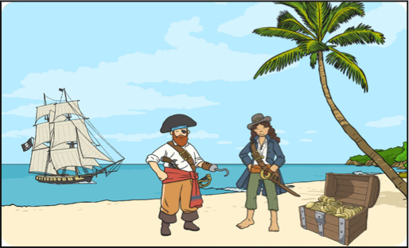
Here are some words that might help you: pirate, ship, treasure chest, gold, island, hook

Maths: (See Hints and Tips for games and activities)
- Pages 100, 101: Data (graphs)
- Pages 102, 103: more/less than
- Pages104: money (sorting 1c and 2c)

Gaeilge:
Go to the Folens Website https://www.folensonline.ie/home/library/programmes/abair-liom-junior-infants/resources/

-Abair Liom A-Resources-Lesson 24 Cinnín Óir agus na Trí Bhéar.
- Listen to the scéal and draw a picture.

- Write some words or a sentence about the picture (Cinnín Óir, na Trí Bhéar, Daidí Béar, Mamaí Béar, Báibín Béar, an coill, babhla, leite, cathaoir, leaba,) Tá Cinnín Óir sa leaba. D’ith Cinnín Óir an leite.,

Tips
To access the Folens Online website follow these instructions:
- Go to FolensOnline.ie and click register
- Select Teacher
- Fill in a username, email and password
- For Roll Number use the code: Prim20

SESE:
Project: This is a project you can work on over the next few weeks. You can add in things you did before Easter too.
Make a time capsule. This is something where you will keep things you made or did over the weeks we are off school. Then when you are older you can open it and remember how you spent this very strange time. You can add to this every day, every couple of days over a week. I want you to include a variety of things including
- drawings you have done
- colouring or cutting
- photos of you and your family over the few weeks or a drawing of your family
- write some sentences, words about things you are doing and how you feel or a letter to yourself when you are older. If you need help you could ask an older brother or sister or you parents to help you with the writing.
- Food labels or wrappers of things you like
- Trace around your hand or foot
- Newspaper
- Or anything else you would like

When we get back to school everyone can show their time capsule and then we will seal them until we open them in 6th class.

