3rd Class Maths Answers Tues 2nd- Fri 5th June
Maths Time Week 35
Monday | Tuesday | Wednesday | Thursday | Friday
1.80  2.80, 90  3. Teacher check  4.Sphere  5.460  6.400  7.280  8.21  9.False  10.690  11.7  12.923, 763, 349  13.9  14.<  15.5 r 3 | 1.14  2.2  3.€8.14  4.12  5.Yes  6.400  7.185  8.340  9. 5/10 or 1/2  10.9  11.120  12.28  13.>  14.5  15.6 | 1.4 hundreds 0 tens 5 units  2.6  3.3  4.7  5.700  6.700  7.156  8.34  9.5.2  10.3  11. 1/4  12.17  13.<  14.360  15.472, 568, 674, 765, 987 | 1.80  2.12  3.True  4.1198  5.3 m 78 cm  6.740  7.600  8.235  9.9 r 2  10.1 hr 50 mins  11.150  12.9  13.=  14.7  15.5 r 2 | 1.50  2.15  3.2  4.59  5.600  6.100  7.324  8. Teacher check  9.170  10.13  11.576, 657, 675, 685, 876  12.36  13.6  14.9  15.3 r 5

Action Maths 3 : Graphs
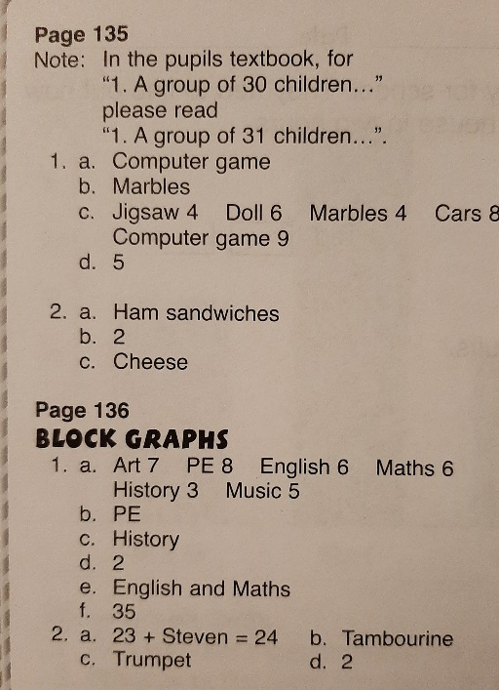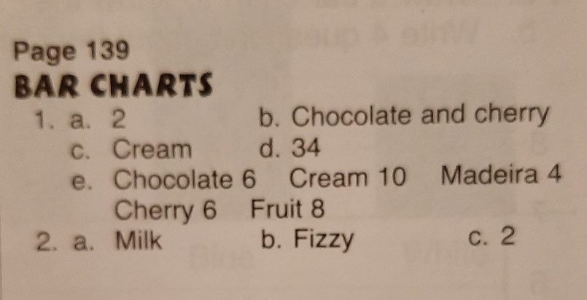

Your graphs will vary slightly but should look similar to these:

