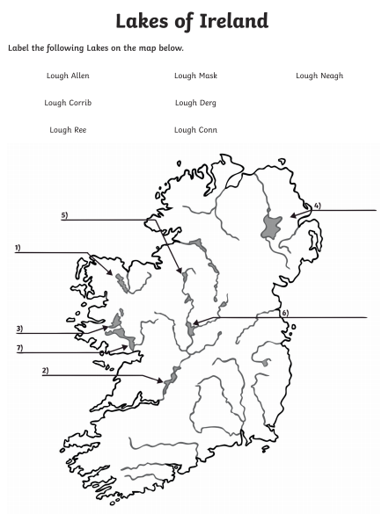

Record your answers

|  |
| --- |
| 1 |
| 2 |
| 3 |
| 4 |
| 5 |
| 6 |
| 7 |