Junior Infants Maths Answers Week 20th April

Page | Answer
99 | 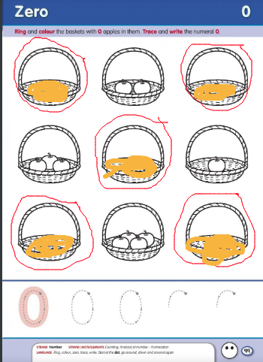  Zero form correctly (see number rhyme posters)
100 | 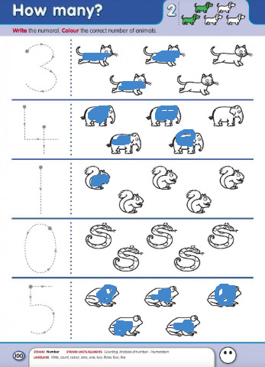  Colour the correct amount and trace the numerals.
101 | 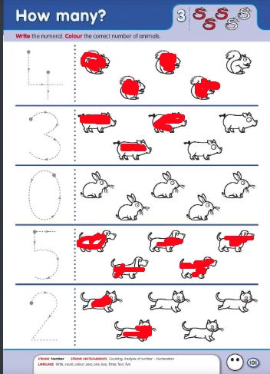  Colour the correct amount and trace the numerals.
102 | Ensure all numerals are formed correctly.  3 and 0 make 3  5 and 0 make 5  0 and 5 make 5  4 and 0 make 4
103 | Ensure all numerals are formed correctly.  4 and 1 make 5  0 and 4 make 4  3 and 2 make 5  0 and 5 make 5

