Junior Infants Attachments

Phonics Word Making
You can use the list of words and call them out to your child or use the pictures and get them to make the words from looking at the picture (or make up your own). We have done both before in school.
Call out some of the following words for your child to make.
Cat  Cap  Can | Hat  Had  Has | Drum  Pink  Swim | Sand  Tent  Frog

Handwriting

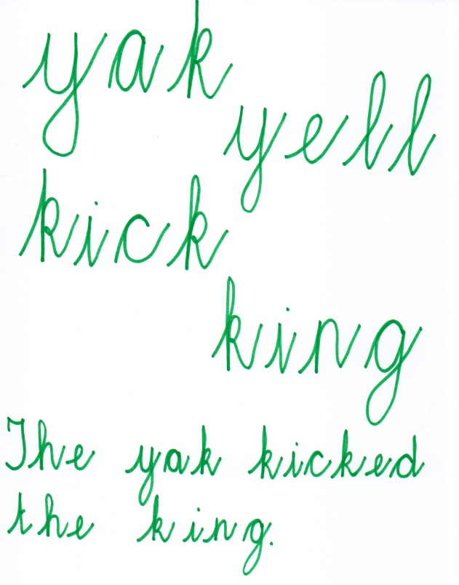

Floating and Sinking

Float Sink

