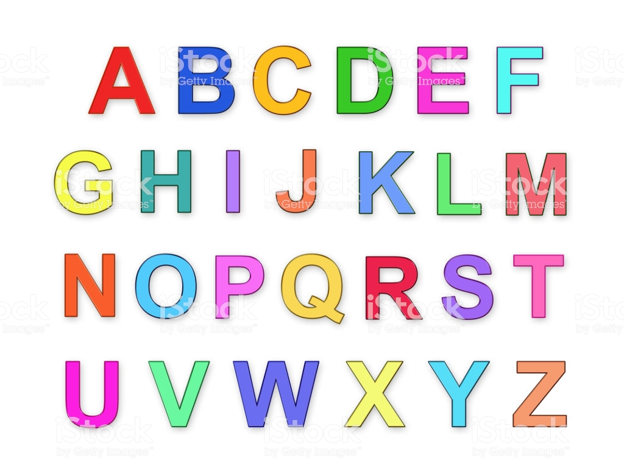
1. An Alphabet Search:
Search for items from A through Z, such as apples, beach balls, coffee cups, etc. until you've worked your way through the alphabet.
List them all. Count up how many items you have found. The winner is the person with the longest list!
Extension: Draw a bar graph showing how many items for each letter you have collected. Compare and contrast.
Why not make it a challenge and try it as Gaeilge!!!!
Have fun!!

2. A photo hunt:
A photograph scavenger hunt is a fun idea and easy to do. Offer the child a digital camera/phone, and then have them take pictures of the items on their list.
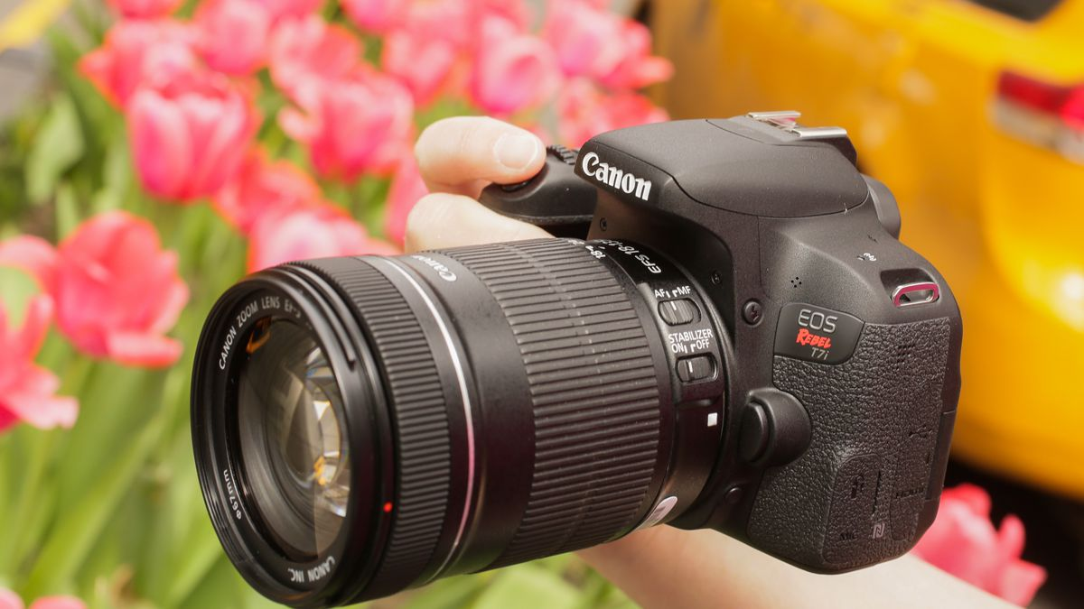
Make a list of things they might see in a particular location, (name a tree, flower, leaf, insect, animal, materials such as wood, plastic, rubber etc.) and give them a set period of time to take photographs of as many as they can.

Extension: They can upload their photos, and then arrange them into a short presentation. Maybe download Microsoft photo story if your computer allows it. A great activity for kids who like projects and working on the computer.

3. A Nature Scavenger Hunt:
Nature Shapes Scavenger Hunt They say there are no straight lines in nature. How many of these shapes can you find? You probably won't see them all. This works well as a Photo Scavenger Hunt.
Find these shapes in natural objects. Check them off the list or take a photo of each.
C-Curve Circle Cone Corkscrew Crescent Horseshoe or U Jagged Edge Oval Rectangle S-Curve Sharp Point
Sphere Spiral Square Straight Line Teardrop Triangle V Wavy Line X Zigzag The most unusual shape you see
4. A Treasure Hunt:
Treasure

Treasure hunt clues are more fun if they require a bit of solving. Puns and rhymes add to the fun. I've created clues to get you started, all involving common outdoor objects.
you’ll figure them all out……..
Extension: Make up your own clues for a treasure hunt around your hous [Grab your reader’s attention with a great quote from the document or use this space to emphasize a key point. To place this text box anywhere on the page, just drag it.]

2. I give privacy from the folks next door.
If you have bad neighbours, you need me mo
Clues
1. I'm a friend to parents who like things neat.
They really like it when you wipe your feet.
2. I give privacy from the folks next door.
If you have bad neighbours, you need me more.
3. Everyone loves me. I'm pretty and smell sweet.
Look down to find me! I'm near your feet.
4. I swing out and in to let you through.
I sometimes creak, and that's your last clue.
5. On me, you can speed like a bird in the sky.
My two wheels will make you fly!
6. I have a ring, but you can't wear it.
Sometimes so loud that you can't bear it.
7. I'm sort of like sneakers, but for a car.
I help it run really fast and far.
8. In day I store the light of the sun.
At night I shine when the day is done.
9. I'm like a small house, but no one lives in me.
Tools and gadgets are all you will see..
10. Some people think I'm nasty and yuck,
But without me for your rubbish, you'd be out of luck!

11. I might be filled by male or female.
Whichever it is, I'm still the mail.
12. Use me to give thirsty plants a drink.
Or use me to clean your car, fast as a wink.
13. Turn me to the left, and you just might get wet.
I'm great for giving a drink to your pet.
14. I make music for you when you're out in the yard.
I make the most music when the wind blows hard.
15. For fine feathered friends, I'm quite a treat.
A spot to raise babies just can't be beat.
16. Climbing me can be quite a lark.
I'm not a dog, but I do have a bark.
17. I make lots of smoke when I get hot.
I make yummy food that you'll like a lot.
18. Hopscotch and skating fit me to a tee.
Don't walk on the grass. Just walk on me!
19. I make your job a little less hard.
I move dirt and other stuff around the yard.
20. I measure all the power you use.
I hope your bill isn't bad news!

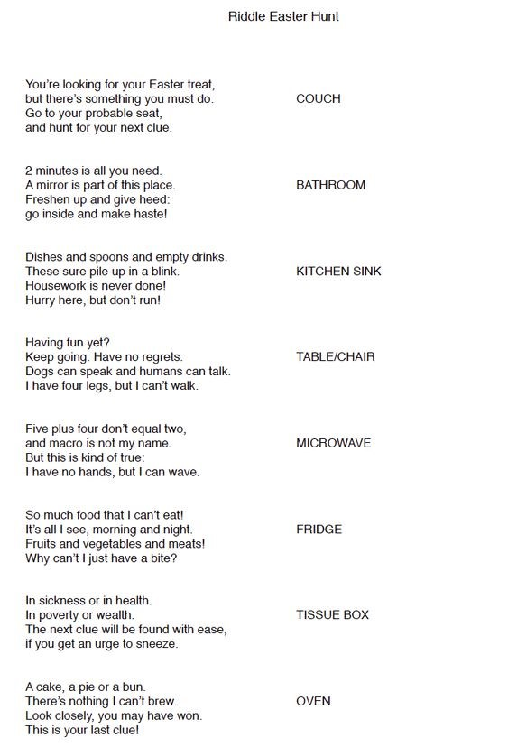
5. An Easter Egg Hunt

