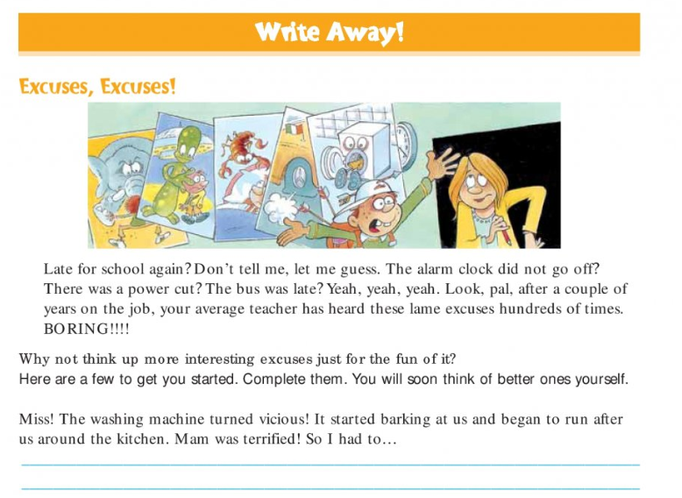
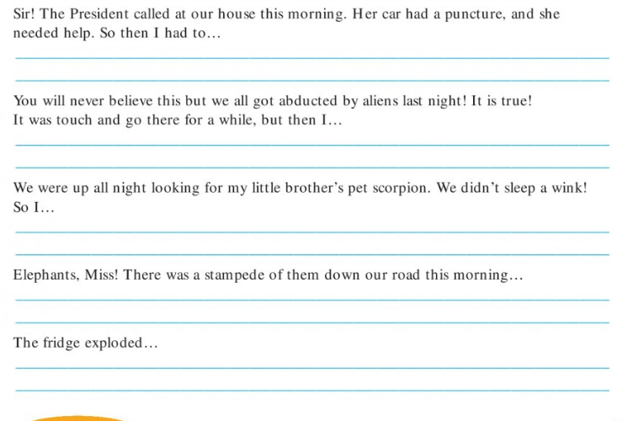
Write a story including one of the sentences above. You could start it with the sentence, or just include it in the main part of the story.

