Cruinniú na nOg Saturday 13th June.
Ireland’s national day of free creative activities for children and young people under the age of 18.
To co-inside with this celebration Scoil San Nioclás will celebrate Creative Week June 8th-12th
Let’s get Creative!
Why not have a go at some of these activities
Drawing | Perspective Drawing  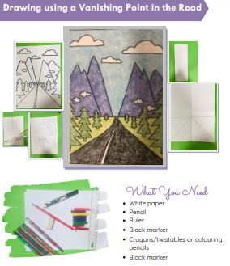
Painting | 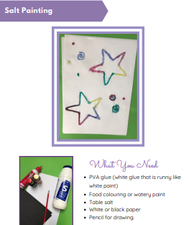
Listen | Write your own song using this handy music tutorial.  https://www.youtube.com/watch?v=Ko8-Edk_hVU&feature=youtu.be
Sing and Dance | This Is Me  Our Creative Associate Aoibheann prepared this for all of us to sing and dance along to. You will need to enter the password creative to access the video.  https://vimeo.com/412450392
Create! | Be a photographer!  Learn some helpful tips on the creative schools website here:  http://www.artscouncil.ie/CSTV/?app=true
Create a Video Game App
Create your own video game. Check out how to do it here:
https://cruinniu.creativeireland.gov.ie/event/create-a-video-game/
English | - Creative writing:  Look at the PowerPoint ‘Story Prompts’ on the school website. Choose any one you like and write a story that is inspired by the picture.  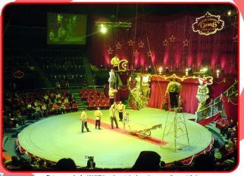  - Role Play  Go into character as one of the characters in your story. Ask a family member to ask you questions. You must stay in role as your character during this activity.
Irish | - An Samhradh  Use the vocabulary you have learned over the past few weeks to write a poem titled ‘An Samhradh’. It does not need to rhyme.  - Cuardach Focal  Find the summer words in the crossword  - Chuir san Ord Ceart  Put the summer words in alphabetical order
Maths  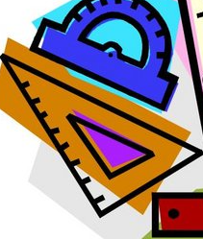 | 5th Class  Pg 35 4 and 5  Pg 36  6th Class  Busy at Maths  Pg. 35  Pg. 36
Sound in Scratch  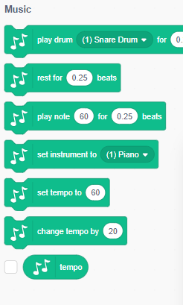 | Create your own beats and music using Scratch  Go to  https://scratch.mit.edu/projects/editor/?tutorial=getStarted  Under the MY BLOCKS code button (in pink) there is a blue and white code button which looks like:  This will give you the codes for making music. Follow the lesson plan to make the music.  *Helpful hint – if you want to duplicate a block. Right click on the block and select duplicate.  Maybe you could also make some music of your own!

