Welcome back- I’m so glad you are here!

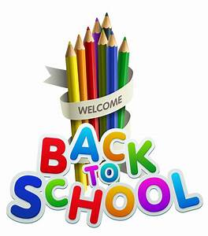

Parent Information

Teaching and Learning
As a staff, we are very aware that the children have been away from school since March 12th. We appreciate the time and effort that went into Home Learning, and we recognise the challenges that Home Learning presented for all families.

Each child will be a different place in relation to his/her learning, and we wish to assure you that staff will take that into consideration when planning for Teaching and Learning during the 2020/2021 school year.

The Department of Education and Skills has published Curriculum guidelines for us, and we ask you to trust our experience and professional expertise as we work with all the children during the return to school.

Supporting the Learning of Children When They Cannot Attend School
If a child is not able to attend school for an extended period of time, the class teacher (and/or the Special Education Teacher, where relevant) will provide work to support the child’s learning at home and this will be shared with parents/guardians.

The majority of parents have already provided an email address at which the school can contact them to support Home Learning. This will be especially important if the school, or parts of the school have to close due to HSE advice. If you have not already done so, it is advised to please contact stabannonschoolstaff@gmail.com and you will be added to the Contact List for Home Learning.

Things to know:
- Storage boxes will be provided for each individual pupil from third to sixth class. The children will keep all their belongings (books, copies ,pencils, scissors,glue etc) in their box.
- Children should have a pencil case that they keep in school. This should be left in school at all times. All equipment should be clearly labelled. We ask that you have a separate supply of equipment at home.
- All children should bring a hand towel to school for the drying of hands after handwashing. These towels should be kept in a zip up bag in their school bags.
- Homework will be phased in throughout the year.

Books we are using:

Junior Infants | Senior Infants
Sounds like Phonics A | Sounds Like Phonics B
Mrs Murphy’s Maths Copies JI (2 pack) | Mrs Murphy’s Maths Copies SI (2 pack)
Go with the Flow A | Go with the Flow B
Go with the Flow Booklet | Abair Liom B Booklet
Abair Liom B Booklet
Dabbledoo music subscription
English readers
Well-being booklet

Stationery
Junior Infant Copies: Plain Day Book 32 pages x5
Project Copy 15 32pages x2
Learn to Write B2 x1
Junior Sum Copy x1
Senior Infant Copies: Plain Day Book 32 pages x4
Project Copy 15 32pages x2
Learn to Write B2 x4

Whiteboard markers x 2
Glue stick
Triangular pencil
Crayons

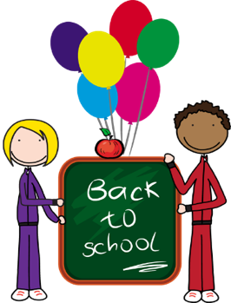
Hello Junior and Senior Infants,
Firstly, I want to welcome all the new Junior infants. I can’t wait to get to know you all. And a very big welcome back to everyone in Senior Infants! I’m sure you have all gotten so big over the summer. I am looking forward to hearing what everyone in Junior and Senior Infants has been up to over the summer.
I hope you are all feeling good about coming back to school. I am very excited, but I am also a little bit nervous and that’s ok! Things are going to be a little different and I understand that some of you might be feeling a little nervous too. It won’t take us long to get used to the changes and I know we are going to have lots of happy learning and fun times together this year.
There are going to be some things that are new and different this year in school. However, there are going to be lots of things that are still the same. We will still get to do Aistear and play everyday. We will do art and play games.
Here are some of the things that are going to be different this year:
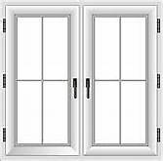
This year we are going to have our own door for going into and out of the school and so will all the other classes. We are very lucky and will be using the big purple door that we always use.
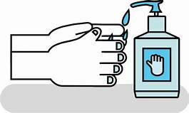
When you come inside the door, there will be hand sanitiser. We will use this every time we come into our classroom and every time we leave our classroom. I will be in the classroom waiting for you each morning! You will be sitting in groups of 5 or 6, like we always do. This year these have another name which is pods, but they are just like our groups last year. And we will still have a table of the week! On your table will be a box with some library books, workbooks, whiteboards and your own tub of play doh. You will also have a pot with your pencil, crayons, scissors, glue and whiteboard marker.
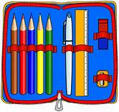
We will keep our pot with our pencil and crayons in school. You can still have a pencil case with pencil and colours, but make sure you keep this at home. We won’t have written homework to start with, but we will get some as the year goes on.
We will be going outside everyday so remember to bring a jacket. You will be playing in zones, like before and you can play with anyone in your classroom. (This is our class bubble).
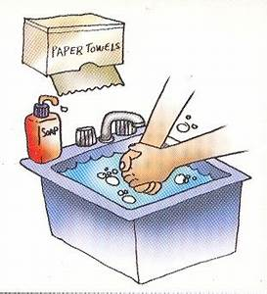
There will be lots of handwashing and hand sanitising throughout the day- before and after you eat, at break-times, at home time and of course after using the toilet.

I am going to wear a visor or a mask some of the time but you don’t need to. We are all going to help each other out to get used to everything and I know you will all be brilliant!
See you all soon!

Ms Hargadon

