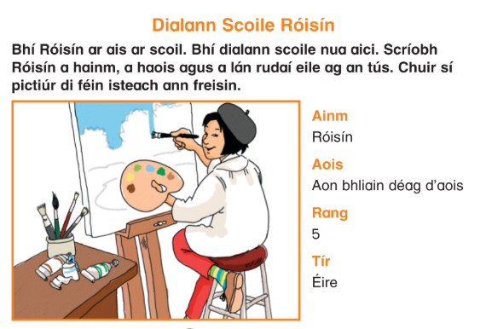
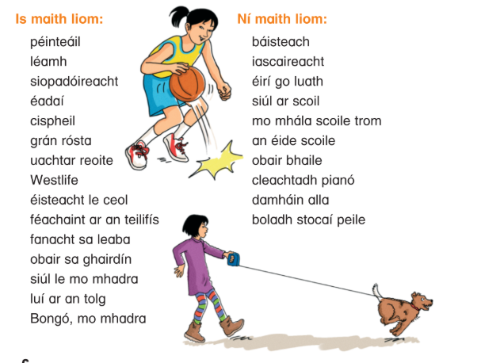

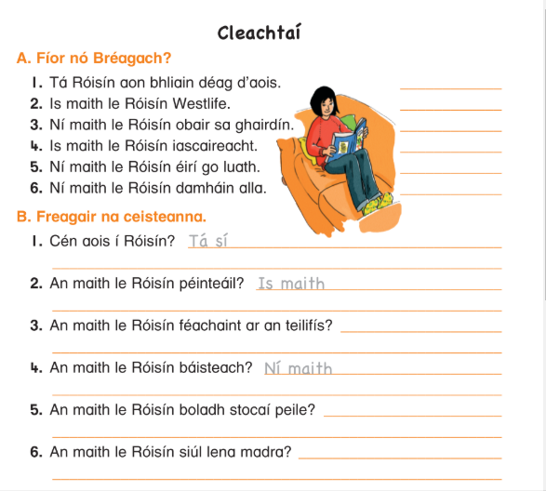
Answer an maith le with Is maith le or Ní maith le
For example for number 2: An maith le Róisín péinteáil (Does Róisín like painting?)
Is maith le Róisín péinteáil

This is a great way to build up some vocabulary this week for your copy. You may know lots of the words already but have a go at looking up some new words. If you get stuck on any you can ask me too.
Some new words might be:

Grán rósta: popcorn
Tolg: Sofa
Boladh: smell

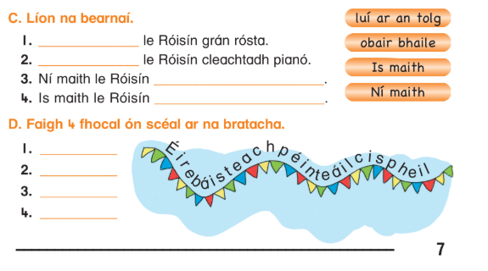
Part D asks you to find some words from the story in the flag.

Good Luck, You’re doing great!

