4th Class Maths Answers Week 2 (Monday 23rd- Friday 27th )
Maths Time 4 Week 27
Mon | Tues | Wed | Thurs | Fri
1. 5.30  2. 2:37  3. 7  4. 1.25  5. 3853  6. 3500  7. Teacher check  8.1350  9. 900  10. 6  11. 10  12. 9009  13. False  14. 2500  15. 10.10, 10.05 | 1. 135  2. 72  3. Parallelogram  4. 1.5  5. 3.0  6. 1260  7. 9000  8. 8  9. 3/4kg  10. 4 hrs 76 mins = 5 hrs 16 mins  11. 150 r 5  12. €7.50  13. 200  14. 4.7 l = 4700 ml  15. 90 | 1. 258  2. 450  3. 10  4. Pentagon  5. 1.2  6. 9102  7. 5  8. 7 hrs 93 mins = 8 hrs 33 mins  9. 72  10. 300  11. 91 r 5  12. Cylinder  13. 0.28  14. 30  15. 5081 | 1. 4  2. 37  3. Teacher check  4. 7  5. €7.99  6. €6.50  7. 8070  8. 8.69  9. False  10. Yes  11. 80  12. 3631  13. 8.99  14. 1560  15. 1450 | 1. 172  2. 142  3. 2.5  4. 44  5. 3.2  6. 5  7. 8/10  8. €106.23  9. 3600  10. 64  11. 10  12. 9909  13. Both  14. 2 hrs 12 mins  15. 400

Action Maths Let’s Look Back 2
P 39
Q1 | Q2
18 | 6
21 | 9
26 | 9
30 | 9
56 | 22
62 | 19

Q3 8006 Q4 1003 Q5 5100 Q699 Q7 Acute Q8 True
Q9
6009 | 8075 | 5818 | 1499 | 8385

Q10
4982 | 2247 | 1518 | 46 | 5886

Q11 4779 Q12 €2900
P40
Q1 9831 Q2 1389 Q3 6880 Q4 H L T E F Q5 Right

Q6
65c | 95c | 49c | 59c | 99c
35c change | 5c change | 51c change | 41c change | 1c change

Q7
1225 | 6665

Q8
5009 | 7885

Q9
639 | 3242

Q10 2784 pages Q11 5169 Q12 2176 Q13 4670

Let’s Look Back 3 P76
Q1
10 | 16 | 22 | 30 | 42 | 56
70 | 74 | 84 | 108 | 186 | 134

Q2
8 | 11 | 22 | 30 | 42 | 56
70 | 74 | 84 | 108 | 186 | 134

Q3 58 Q49 Q5 1 Hour, 41 mins Q6 52 mins Q7 2hrs 43 mins Q8 12.07pm

Q9
2400 | 2550 | 3840 | 5220 | 5520 | 6580
Q10 1008 Q11 €1,728 Q12 7hrs 44 mins
Q13
268 | 213 | 184
27 | 122 | 47

P77
Q1 2C Q2 €1.75 Q3 €20.75

Q4 | Q5 | Q6
24 | 42 | 9
16 | 48 | 9
45 | 48 | 9
14 | 36 | 11
81 | 5 | 5
56 | 63 | 6
40 | 0 | 8
21 | 30 | 9
25 | 88 | 6
72 | 48 | 7

Q7
33 c+ 15 c =48c
48c + 32c =80c
45c + 15c = 60c
48c + 23c = 71c

Q8
10c | 14c | 8c
16c | 14c | 16c
8c | 16c | 18c

Q9 Teacher check

P78
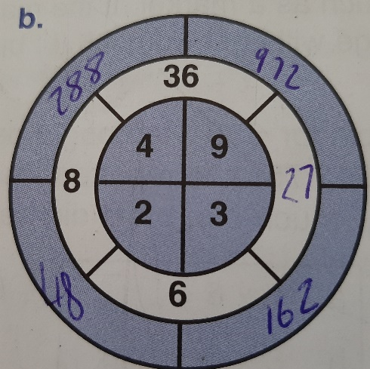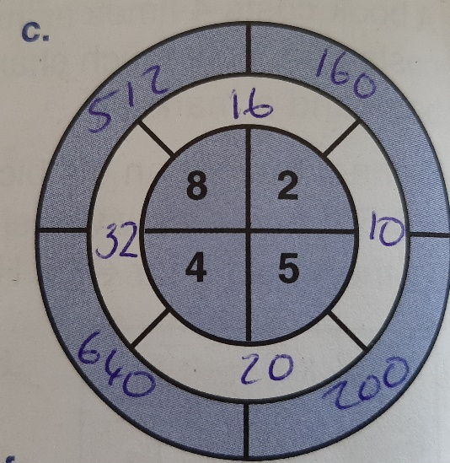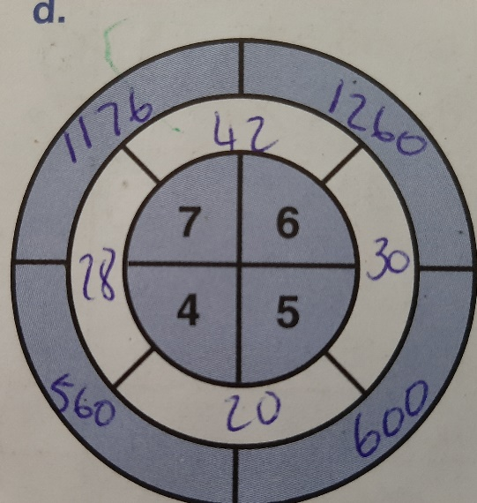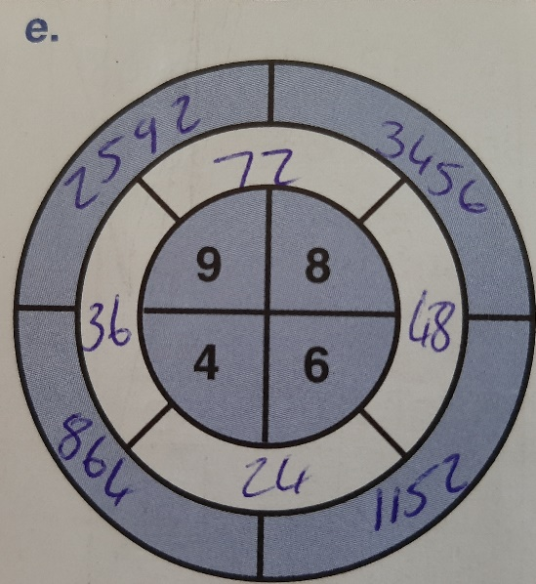
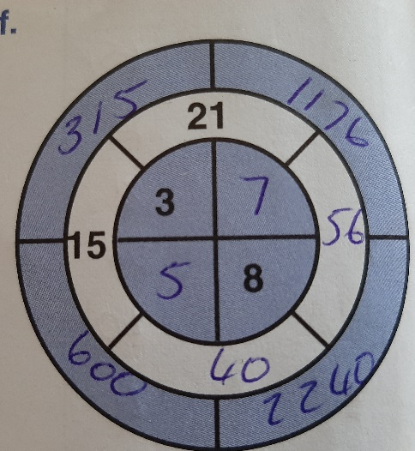

Q2
14 | 335

Q3
570 | 923

Q4
584 | 208

Q5 9400 pages

