Monday 18th – Friday 22nd May 4th Class
Daily Activities
- Maths Time week 33
- Tables Champion week 30

English:
- Reading: Lift Off : p220 A Drive in the Motor Car
- Activities: Portfolio book p A,B,Challenge,D,E & G
Part G this week is narrative writing. A Narrator tells a story. You have 2 weeks to complete this. First of all- think of a title for your story and draw a mind map, including any words or pictures that come to mind. Next, plan and draw out the beginning, middle and end of your story- just like we do in class. When you have it planned, you can start writing. Remember to include lots of descriptive words and wow words (adjectives) Try keep it all in the past tense!

Remember to keep reading!!
Continue your Covid 19 journal. Why not try a factfile, include your name, age, address height, hair & eye colour and your hobbies, hopes and wishes.

Maths: Time
- Action Maths p 56 & 57(have a read and answer orally –you do not need to write the answers)
- Acton Maths p 58- Digital Time Q 1,3 – 7
P59 , 60, 61 & 62

Remember there are 60 minutes in one hour. When you are adding minutes, if your answer is more than 60 minutes, you will need to change it to hours and minutes.
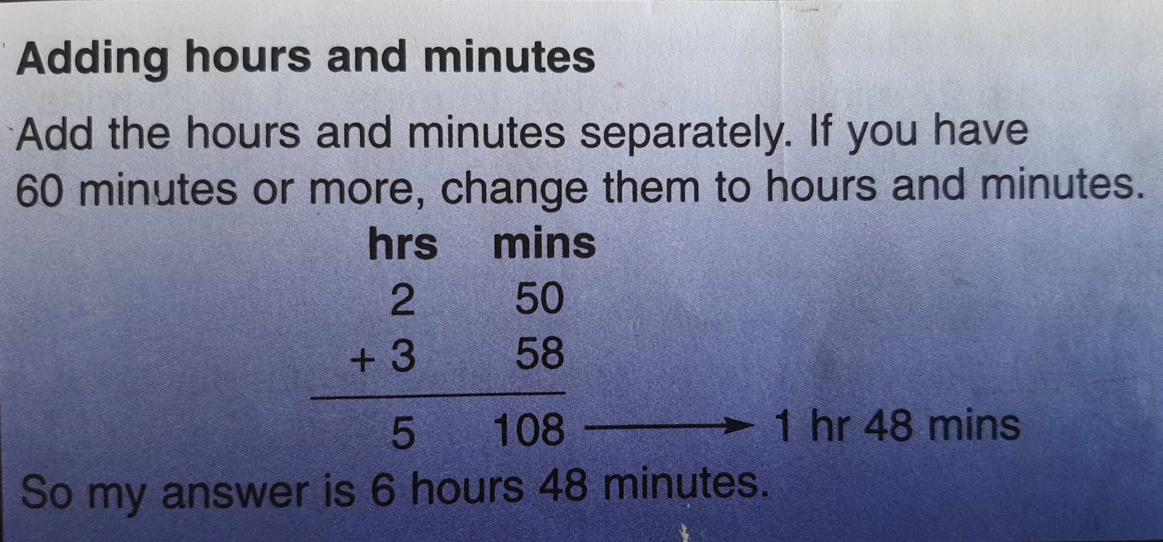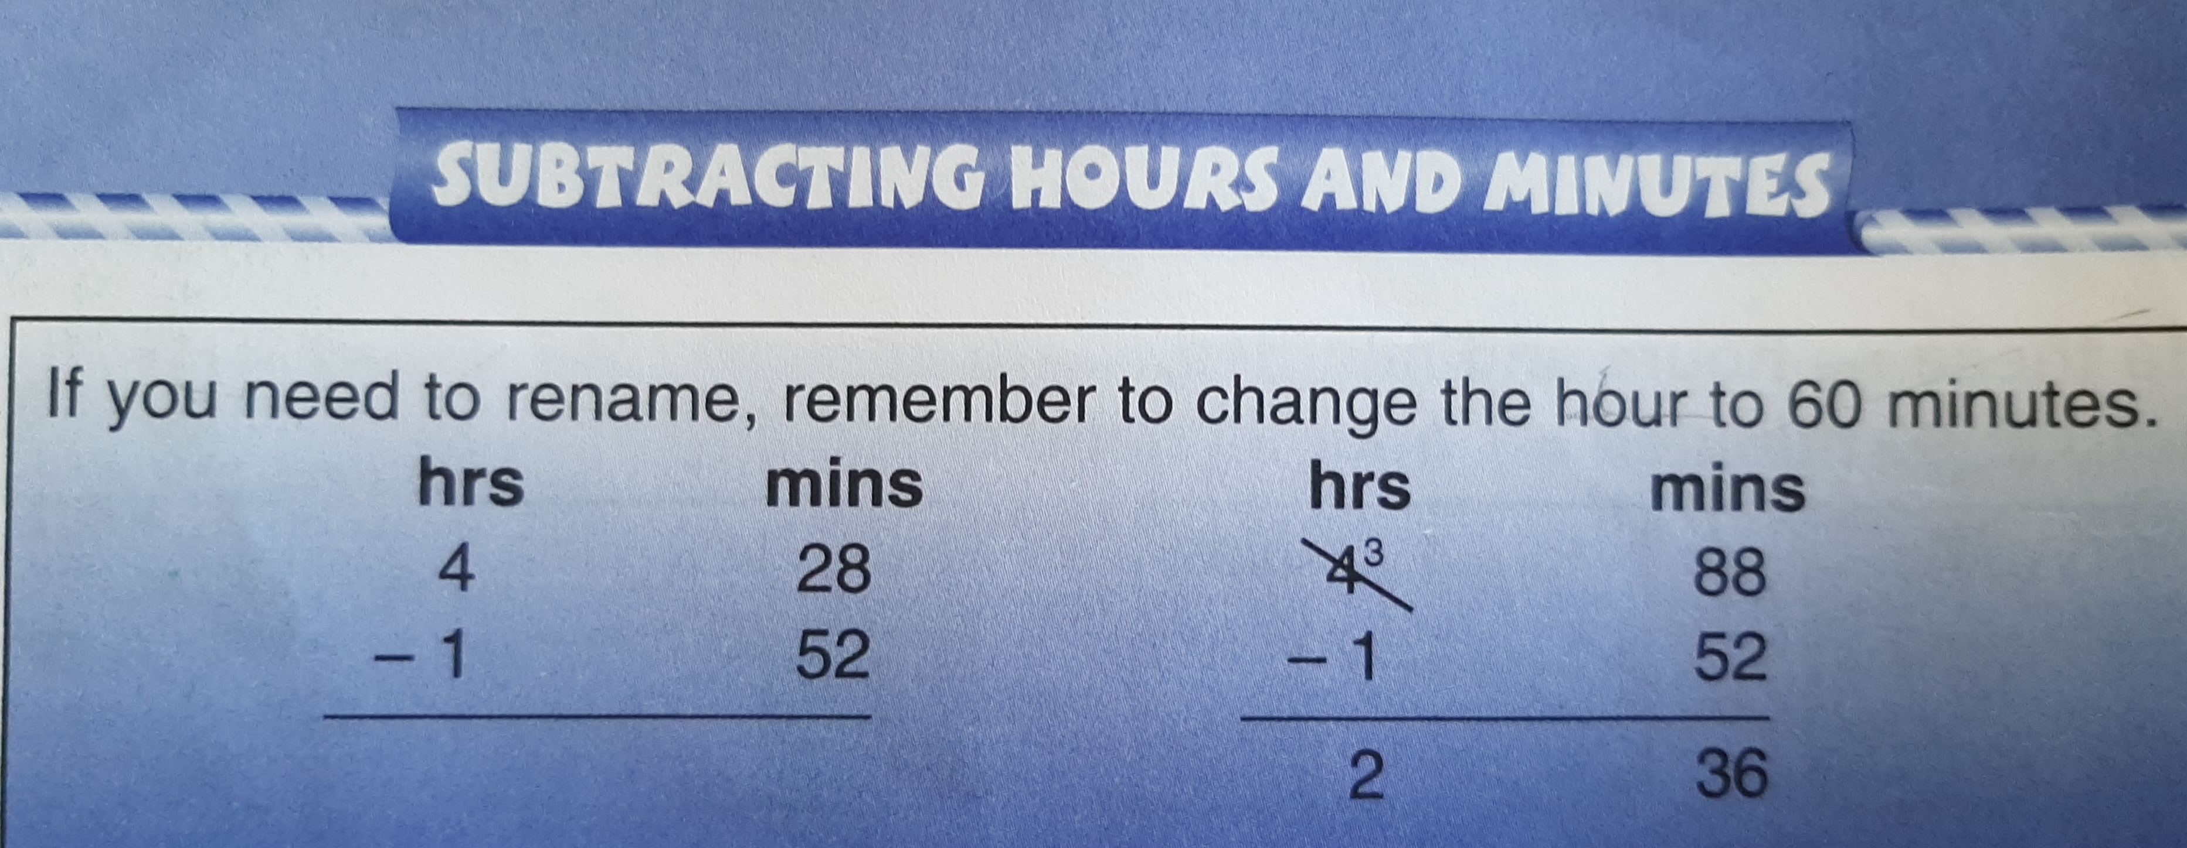
When you are subtracting, if you need to rename, remember 1 hour will change to 60 minutes

Gaeilge:
- Léigh : Ar Scoil Ag Dul ar Scoil Déan na ceisteanna
- Tarraing pictiúr den seomra ranga féin agus cur lipéad ar cúpla rud (label some of your picture- use your words from Fuaimeanna agus Focail to help you)
- Scríobh: Abairtí

Abairtí
Choose 8 words from Fuaimeanna agus Focail 4, Aonad 12 (An Scoil)
Put each one in a sentence

SESE: Geography
- The Munster Challenge
Art
- Let’s get creative using our environment!
Go on a nature walk or hunt around your garden. Collect some twigs, leaves, grass and stones. Or anything else you can find! What can you create? Have a look at these examples.
I’d love to see your finished pieces!

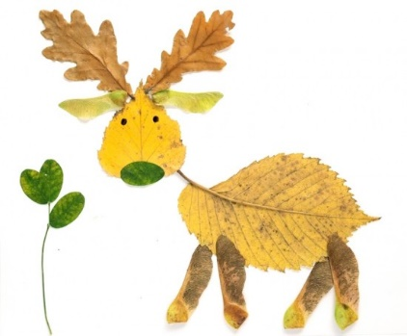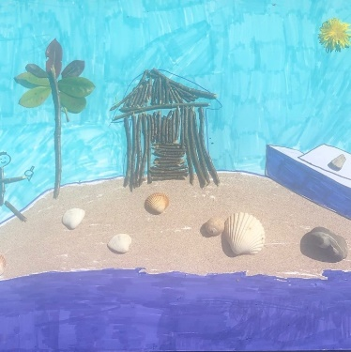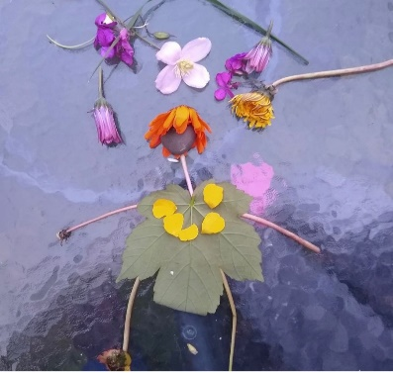

Remember if you have any questions or if you’d like to send me some of your work (or even just to say hello and let me know what you’ve been up to) you can email mrsduffystabannon@gmail.com.
This week I’d love to see your Irish ceisteanna and your nature art. You can send anything else you’d like aswell.
Any of you who are in Mrs Stanley’s groups can contact her at mrsstanleystabannon@gmail.com
Stay Safe
Mrs Duffy

