Monday 25th – Friday 29th May 4th Class
Daily Activities
- Maths Time week 34
- Tables Champion Check Up 4

English:
- Reading: Ready to Go : 228 Cars
- Activities: Portfolio book p118 A,B,Challenge, C, D & E
Continue your narrative writing from last week. By now you should be well on your way! Remember to include a title for your story. CHECK back on your mind map and story plan if you need to. Remember to include lots of descriptive words and wow words (adjectives) Try keep it all in the past tense! You can add some illustrations if you like.
Remember to keep reading!! 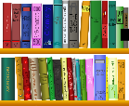
Continue your Covid 19 journal. Why not trace you hand and foot and include it as a memory.

Maths: Lines and Angles
- Action Maths p 32-38
- Right angles activity sheet- can you follow the directions to sail safely across the ocean?
- Try writing your own for activity two.

This is revision and most of it can be done orally. Try the drawing activities. Try make the plumb-line too!
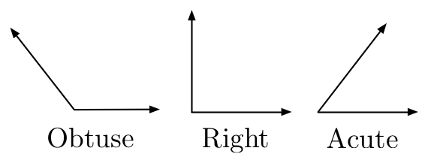

Gaeilge:
- Léigh : Bia –. Bia ar Fud an Domhain
- Tarraing pictiúr Draw a picture of your favourite dinner Label your food- use your words from Fuaimeanna agus Focail to help you)
- Scríobh: Abairtí

Abairtí
Choose 8 words from Fuaimeanna agus Focail 4, Aonad 15 ( Bia)
Put each one in a sentence

SESE: History (Stories)
- Have a look at the power point on The Trojan Horse (some of you might know the story)
- Try re-telling the story in your own words
- Draw a picture of your favourite part
- Complete the wordsearch
- If you like, research some other Greek myths

Art : Lines and Angles
- Use your ruler to draw some lines and angles on a page. Colour them in

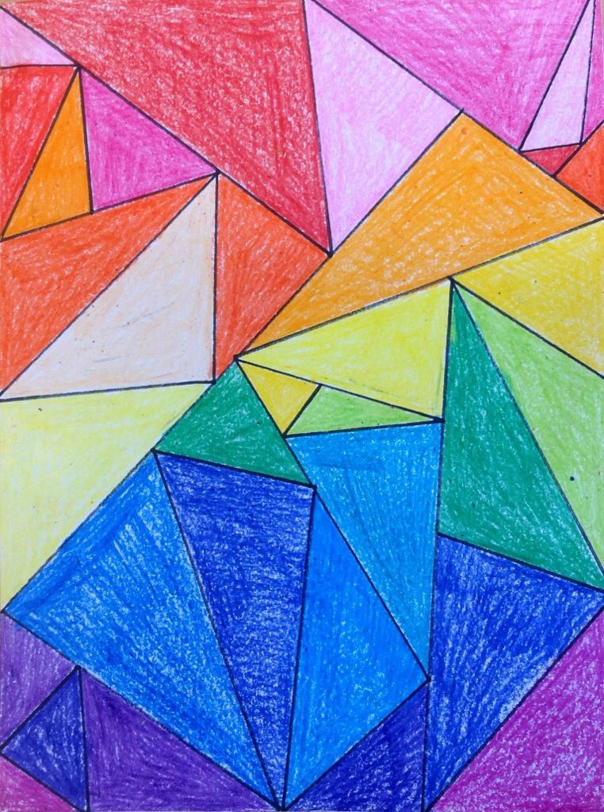

Remember if you have any questions or if you’d like to send me some of your work (or even just to say hello and let me know what you’ve been up to) you can email mrsduffystabannon@gmail.com.
This week I’d love to see your finished story and your Irish sentences.
You can send anything else you’d like aswell.
Any of you who are in Mrs Stanley’s groups can contact her at mrsstanleystabannon@gmail.com
Stay Safe
Mrs Duffy
