Maths Answers 4th Class Tuesday 5th-Friday 8th May
Maths Time Week 31
Monday | Tuesday | Wednesday | Thursday | Friday
1. 9  2. 6  3. 76  4. 18  5. 2.5  6.13 1/2kg  7. 9000  8. 3/4  9. 5  10. 0.9  11. 28  12. 4.91  13. 4  14. 8  15. 4 | 1. 45  2. 70  3. 2.2  4. Teacher check  5. 77  6. 2604  7. 5830  8. 10  9. 0.5  10. Yes  11. 96 r 4  12. 6.55  13. 3 hrs 13 mins  14. 50  15. 25 | 1. 6  2. 300  3. Octagon  4. 8  5.4 56/10 0or4 14/25  6. 6900  7. 3  8. €22.69  9. Horizontally symmetrical  10. 1.87  11. €31.00  12. False  13. 30 km  14. 8290  15. 200 ml | 1. 4  2. 700  3. Answer will vary  4. Answer will vary  5. 2  6. 6800 grams  7. 2500  8. True  9. 550  10. 10:40  11. 32 r 1  12. 3719  13. €11. 20  14. 6650  15. 9/12or 3/4 | 1. 81  2. 10  3. Teacher check  4.3 7/1 0 0  5. 7052  6. 9  7. 9330  8. 4 hrs 17 mins  9. 1150  10. 1.69  11. 1000  12. 7/8  13. 1.46  14. 10 cm  15. 15 cm²

Action Maths : Weight
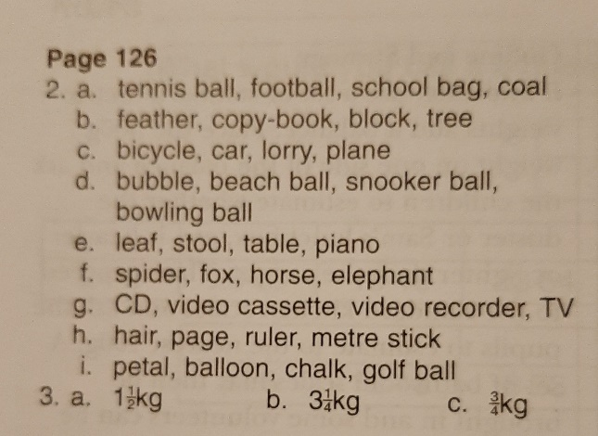

P128
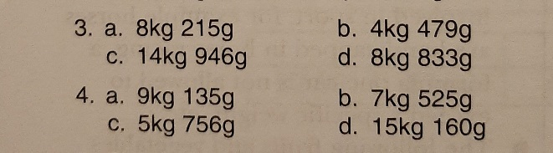
P129
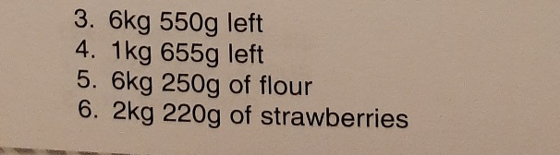
P130
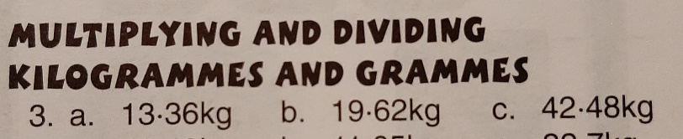
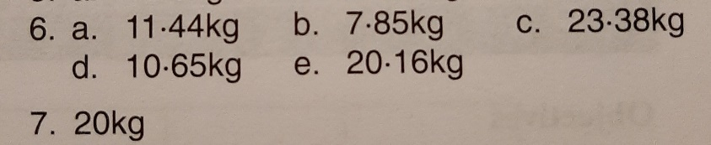

P131
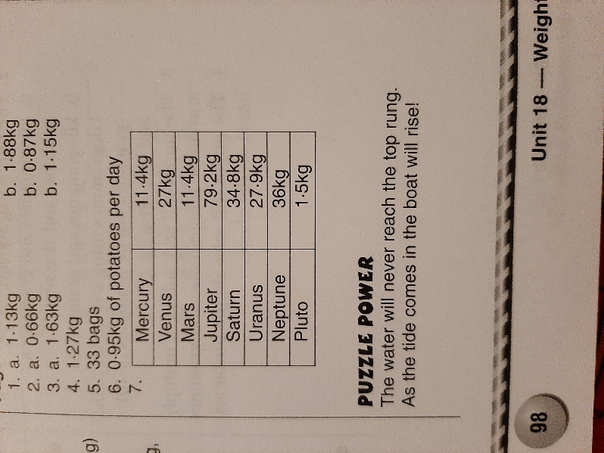

Tables Champion Week 28
