4th Class Maths Answers Monday 20th – Friday 24th April
Maths Time 4 Week 29
Mon | Tues | Wed | Thurs | Fri
1. 4.8  2. 850  3. 5  4. 0.75  5. 6  6. 9.9  7. 4500  8.3 4/10 0  9. No  10. 45  11. False  12. 3 hrs 9 mins  13. €8.45  14. 4.65 kg  15. 6000 | 1. 200  2. Teacher check  3. 4  4. 126  5. True  6. 8  7. 5030  8. 1/2  9. €120  10. 3 1/4 kg = 3250 g  11. 20  12. Teacher check  13. 3.33  14. 2200 g  15. Shop A | 1. 7  2. 600  3. 9  4. 4.01  5. 3000  6. 120  7. 5 hrs 22 mins = 4 hours 38  mins  8. 7080  9. 3  10. 2.69  11. 9678, 9786, 9876, 9986  12. 0.18  13. 159 r 3  14. 10 cm, 6 cm²  15. 0.4 | 1. 77  2. Yes  3. 2.12  4. 29  5. 1.75  6. 9000  7. 4/5  8. 2500  9. 1.5  10. 12.05  11. 48  12. 2645  13. 3000  14. 4975  15. 78 | 1. 3.42  2. 950  3. 43  4. 900  5. 5.5  6. 3384  7. 9830  8. 4 hrs 27 mins  9. 10 3/4kg = 1075 g  10. 1.24  11. €69.60  12. 6/9or 2/3  13. 9.04  14. 2.7  15. 700 g

Action Maths – Capacity
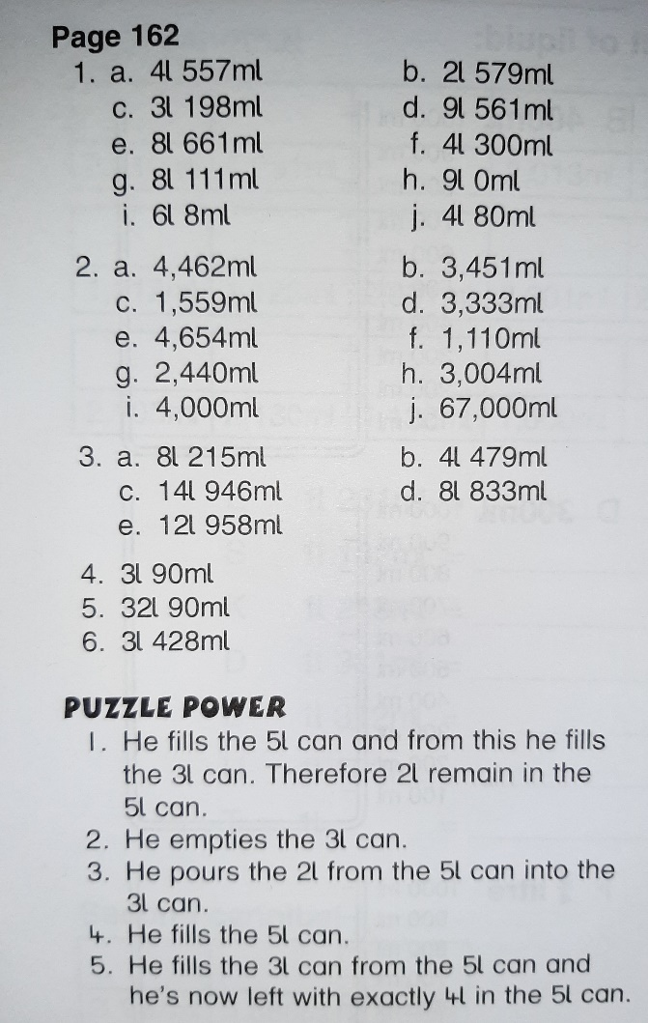
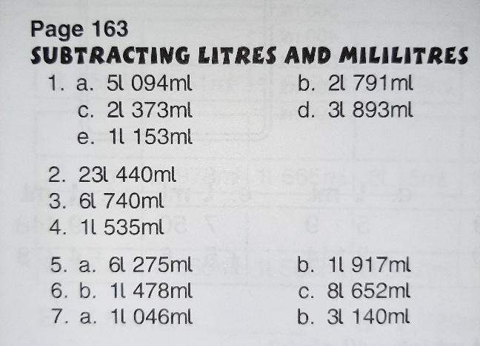
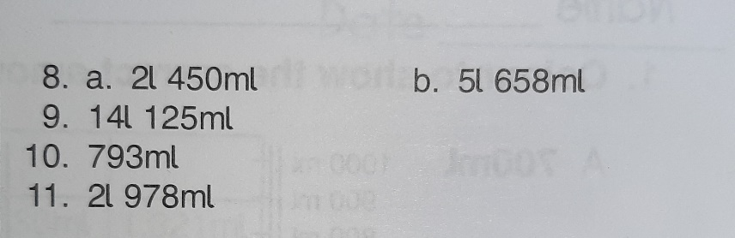

Tables Champion Week 26
