4th Class Maths Answers Monday 11th – Friday 16th
Maths Time 4 Week 32
Monday | Tuesday | Wednesday | Thursday | Friday
1. 9  2. 1.00, 1.01  3. 160  4. 9 hrs  5. 5  6. Answer will vary  7. 9000  8. >  9. 285  10. 1050  11. 379 r 1  12. 2101, 1210, 1120, 1021  13. 2/5  14. Teacher check  15. 3 | 1. 5  2. 6.2  3. 11  4. 632  5. 2  6. 438  7. 3/5  8. €55.11  9. True  10. 10.1  11. €6  12. False  13. 0.55  14. 1000 g  15. 1 | 1. 30  2. 983  3. 25th August  4. 3.75  5.4 6/10 0  6. 2592  7. 5100  8. 9/12  9. 600  10. 5 hrs 22 mins  11. False  12. 6616  13. 4.3 l = 4300 ml  14. 15  15. 15 | 1. 54  2. 500  3. 650  4. Pentagon  5. 1.25 kg  6. 390  7. 9900  8. 1/2  9. 0.15  10. 2 mins 20 secs  11. length × width = area  12. 14.9  13. False  14. 20  15. 5 | 1. 9  2. 9000  3. 37  4. 663  5. 4  6. 1170  7. 7640  8. 3.59  9. 4/10  10. 1.4  11. 81 r 6  12. 3/9or 1/3  13. 4.54  14. €6.50  15.6 3/4l = 6750 ml

Action Maths: Area
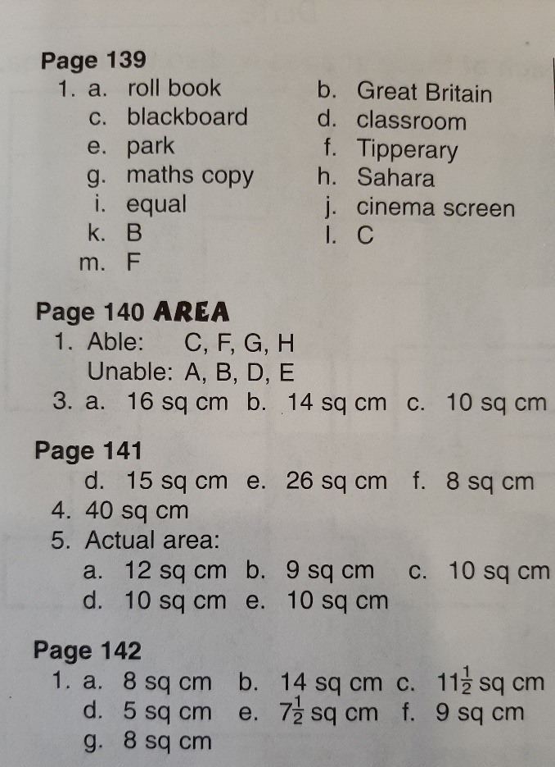

Tables Champion Week 29
