Design your own Shopping Centre 4th Class

You are going to design your own shopping centre.
Use squared paper. Remember you can use 2 half squares to make a full square

You must include:
- A supermarket which covers 20 squares
- A sports shop which covers 16 squares
- A clothes shop which covers 14 squares
- A café which covers 9 squares
- A bookshop which covers 14 squares
- A meeting area which covers 12 squares
- A sweet shop which covers 4 squares
- A cinema which covers 35 squares
- Another 2 shops of your choice

Here is an example of one:

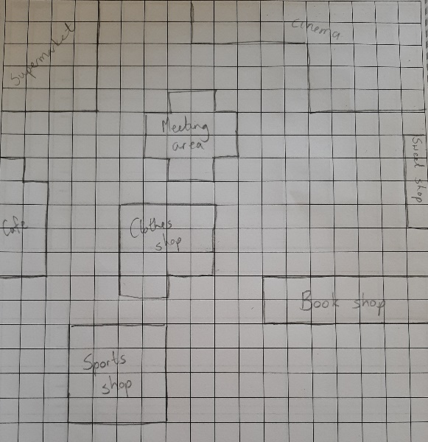

You can colour it in and add some shoppers too, if you like.

