4th Class Maths Answers Tues 2nd-Fri 5th June
Maths Time 4 Week 35
Monday | Tuesday | Wednesday | Thursday | Friday
1. 216  2. 7  3. 49  4. 10  5. 5632  6. 7  7. 6280  8. 2250  9. 1950  10. True  11. Shop 2  12. 5/6  13. 1.2  14. Teacher check  15. 120 | 1. 8  2. 1  3. 60  4. 490  5. 3.46  6. 4 hrs 30 mins  7. 12/12  8. 1320  9. Y, X, H and I  10. 5000  11. 71 r 3  12. 1055  13. 5 hrs 24 mins  14. 300  15. 1000 | 1. 105  2. 6/6  3. 4.25 kg  4. 73  5. True  6. 115  7. 4  8. 6.41  9. 21  10. 7.9  11. 5/10  12. 2.02  13. Teacher check  14. 500 g  15. 9019 | 1. 125  2. €7.50  3. 200  4. 6 vertices, 9 edges, 5 faces  5. 3.59  6. 0.65  7. 8890  8. 21  9. 1.8 km  10. 15  11. 313 r 2  12. 3889  13. 3 hrs 26 mins  14. 44  15. 4500 | 1. 144  2. 6  3. 27  4. Teacher check  5. 7.06  6. 348  7. 4500  8. 15 hrs 106 mins = 16 hours 46  mins  9. 7500  10. 15.9  11. €1.15  12. 6 cm  13. 3 cm²  14. 7/1 0  15. 10.04
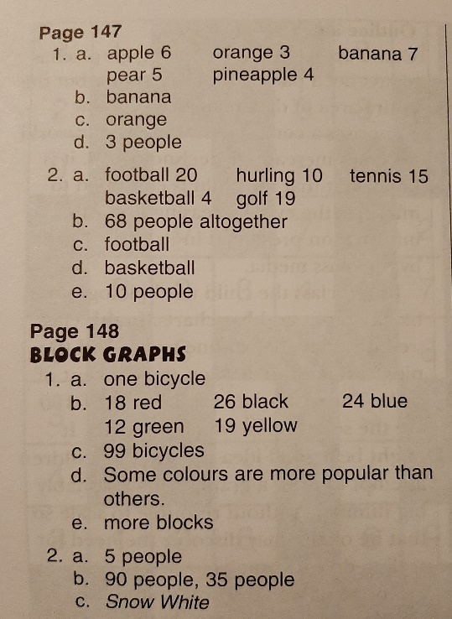
Action Maths: Graphs 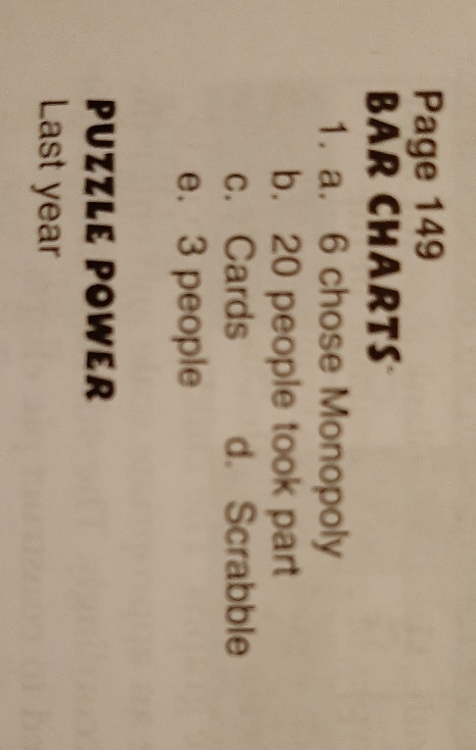
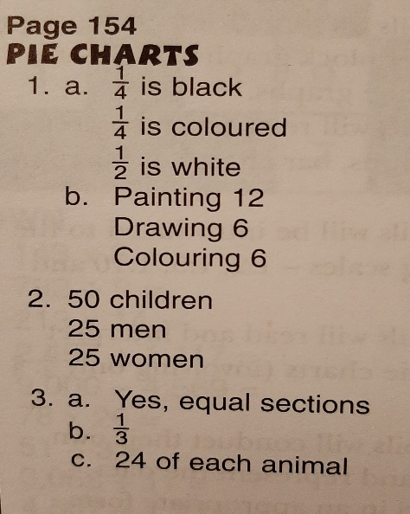

Your graphs will vary slightly but should look similar to this:
