3rd Class Maths Answers Week 1 (Monday 16th-Fri 20th )
Maths Time 3 Week 26
 | Mon | Tues | Wed | Thurs | Fri
 | 25  12  4  Teacher check  29  40  74  6  Teacher check  230  Cuboid  23  >  6  7 | 234  10  5  €8.34  Pyramid  500  115  4  0.1  False  450  8  55  =  1.4 | 30  6  6/8  €3.87  760  30  551  Teacher check  6  0.2  30  6  >  1.3  5 | 352  12  3  False  20  30  9  56  4  7  430  20  24  1/10, 1/2, 3/4  8 | 415  12  3  Teacher check  €3.19  50  135  298  7  0.3  270  10  33  1.5  >

Action Maths 3 Let’s Look Back 1
P 5 Q1
a 9 o’clock | b 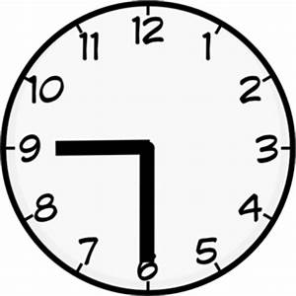 | c €1.09
d 2c | e milk  yoghurt  eggs  cheese | f metre

P6
Q1 | Q2 | Q3
10  12  12  11  17  5 | 16  4  18  12  14  20 | 4  7  2  2  4  8
Q4 A.40 B.80 C.90 D.90 E.50 F.30

Q5 4 o’clock Quarter past 11 half past 10 quarter to 5

Q6
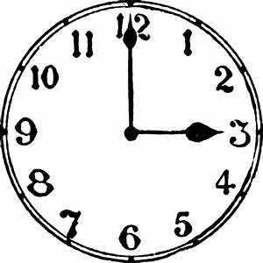 | 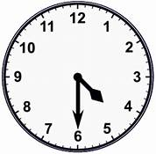
3:00 | 4:30
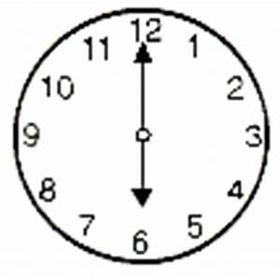 | 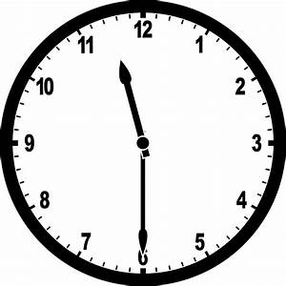
6:30 | 11.30

P7
Q1 a 12 b 16 c 22 d 39 e32 f35 g 40 h9 i 34
2. TEACHER CHECK
3. a 4,5,6,7 b.16,17,18, c31,32,41 d 64,65,66,67,85

P8
- A 39 B 38 C 55 D 39 2. A 51 B 63 C 76 D 90

- A 80 B 48 C 98 D 60

Q4.
5 tens 12 units
3 tens, 13 units
6 tens, 15 units
1 ten, 11 units
5 tens, 16 units

Q5 a 54 b44 c19 d19 Q6 a 49 b52 c76 d15

P9
Q1
Magic number = 15 Magic number = 9 Magic number 12 Magic number =9
Q2
A One half b one quarter c one half

Q3
A circle b square c rectangle d triangle e oval

Q4
A 16c b 27c c38c d €1.07 or 107c

