3rd Class Activities Monday 18th – Friday 22nd May

English:
- Reading: Ready to Go p210 The End of Dinosaurs

Read a page or two a day. When you have finished try the questions

- Questions: Ready to Go (reader) p 214 part A q1-6
part B q1 & 4

- Activities: Portfolio book p 116 part E
P 117 part G
(Activities E & G can be completed before the story has been read)
Story writing
This week you are going to start a story. (Part G) You have 2 weeks to plan and write your story. Your story title is A Dinosaur At School
First draw a mind map, including any words or pictures that come to mind.
Next, plan and draw out the beginning, middle and end of your story- just like we do in class. Use the template to help you
When you have planned your story, you can start writing. Remember to include lots of descriptive words and wow words (adjectives) Try keep it all in the past tense!

Maths: Time
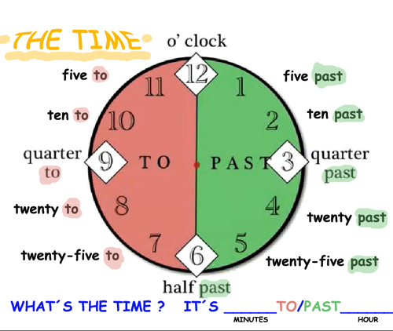

- Action Maths p 67 (minutes past – use the clocks below for Q2)
P68 (minutes to – use the clocks below for Q2)
P69 q1
P71

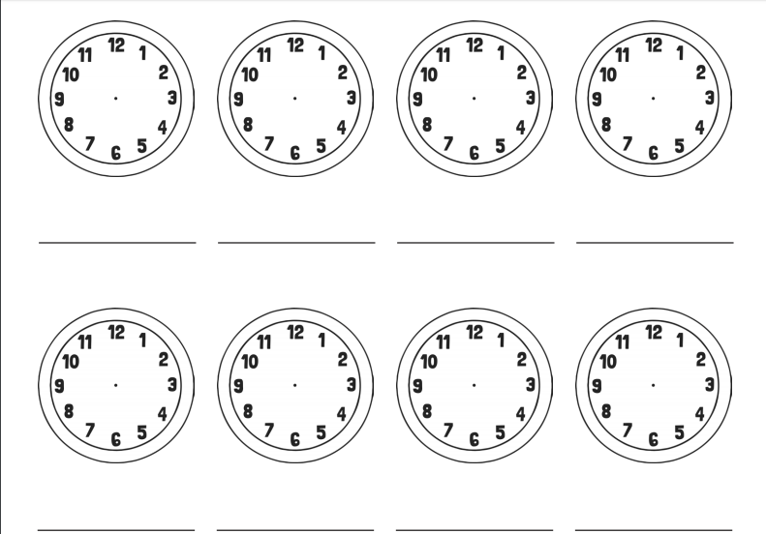

Plan your story – Make a Mind map

Look at the title. Write down all the things you think of when you read it.

Think about…

Who is in your story?
Where will your story take place?
What can your characters see, hear, smell, touch, taste…?
Will your dinosaur be scary, funny, friendly or naughty?
Will your dinosaur cause trouble?
What will the teacher think or do? What will the children think or do?

A Dinosaur at School

Story Planner – Draw your Story
Beginning
Middle
End

When you have planned your story, you are ready to write! Check back over your plan if you need to.

