Maths Answers 3rd Class Tues 5th-Friday 8th May
Maths Time Week 31
Monday | Tuesday | Wednesday | Thursday | Friday
1.12  2.70  3.€8.43  4.60  5.123, 345, 465, 678, 897  6.400  7.96  8.10  9. 6/8 or 3/4  10. 7/1 0  11.412  12.3 r 1  13.27  14.> | 1.3 hundreds 5 tens 3 units  2.50  3.2  4.42  5.Prism  6.300  7.176  8.100  9. 4/8 or 2/4  10.7  11.5 r 2  12.50  13.6  14.>  15.30.2, 22.3, 3.0, 0.3 | 1.40  2.14  3.100, 243, 456, 507, 987  4.Teacher check  5.€7.68  6.200  7. Teacher check  8.11  9. 9/10  10.1 hr 20 mins  11.9 in 95.1  12.4 r 3  13. 5/10  14.42  15.> | 1.539  2.24  3.3  4.€3.70  5.9 m 84 cm  6.634  7.132  8.12  9.550  10.450  11.2 r 3  12. 2/8  13.True  14.7  15. 4/10 | 1.40  2.156, 209, 299, 736, 800  3.35  4. Teacher check  5.€4.72  6.800  7.172  8.31  9. 4/10  10. Teacher check  11.567  12.5 r 3  13.0.5  14.80  15.7

Action Maths : Weight
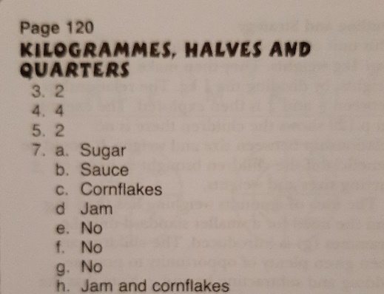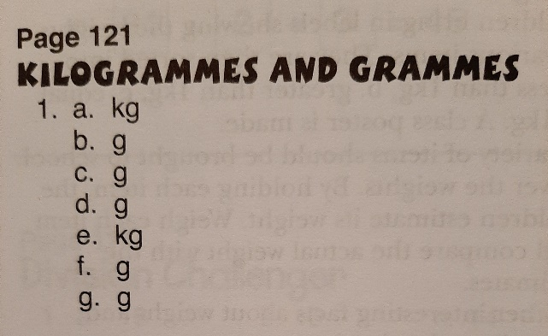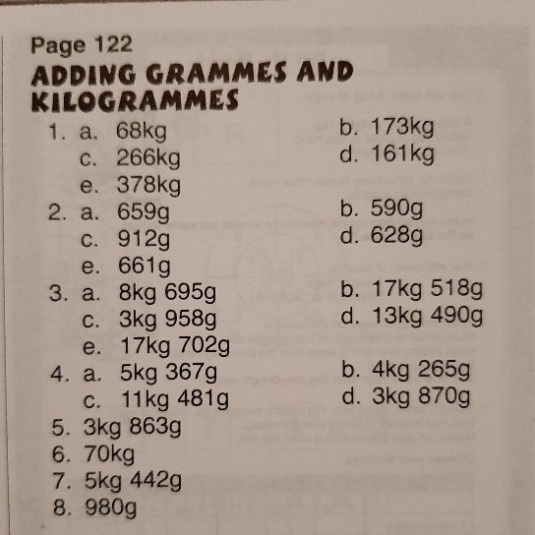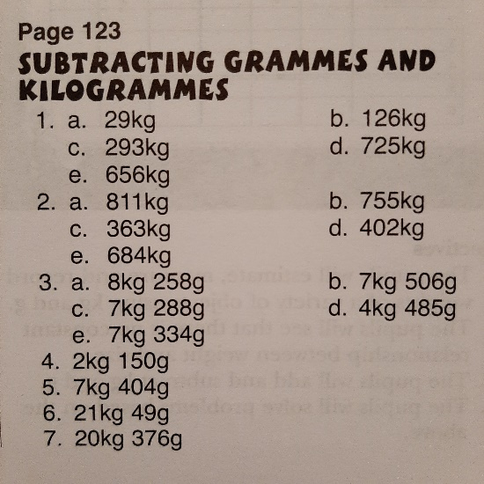

Tables Champion Week 28
