3rd Class Maths Answers Monday 25th – Friday 29th May
Maths Time 3 Week 34
Monday | Tuesday | Wednesday | Thursday | Friday
1.158  2.18  3.2  4.€7.49  5.3 m 99 cm  6.200  7.1 hr 40 mins  8.162  9.43  10.False  11.6 r 1  12. 2/8  13.24  14.23  15.True | 1.50  2.18, 24  3.15  4. 3/8  5.€7.16  6.200  7. Teacher check  8. 3/10  9.32  10. 3/10 of 1 kg  11.30.3, 30.0, 3.0  12.6 r 4  13. 5/10  14.11  15.True | 1.538  2.80  3. Teacher check  4.No  5.840  6.600  7.154  8.8  9. 2/8 or 1/4  10.True  11.999  12.6 r 3  13.100  14.6  15.3 | 1.20  2.12  3.4  4.42  5.6 corners 5 faces  6.700  7.332  8.11  9. Teacher check  10.3.8  11.987, 876, 789  12.3 r 1  13.41  14.=  15.9 | 1.705  2.90  3.14  4.2  5.29  6.800  7.282  8.31  9.50  10.650  11.456, 466, 556, 644, 654  12.6 r 1  13.28  14.=  15.9

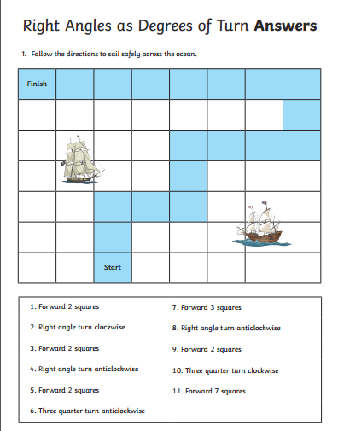

Tables Champion Check Up 4
