Maths Answers Monday 20th – Friday 24th April
3rd Class
Maths Time Week 29
Monday | Tuesday | Wednesday | Thursday | Friday
1.467  2.60  3.True  4.€6.34  5.500  6.800  7.132  8.6  9. 3/10  10.133, 423, 433  11.850  12.3 r 2  13.4  14.53  15.= | 1.12  2.3  3.7:45  4.€12.77  5.False  6.40  7.200  8.10  9. 8/10  10.0.8  11.567  12.35  13. 1/2 3/4 9/10  14.9  15.2 | 1.428  2.15  3. Teacher check  4.12  5.Cylinder  6.91  7.97, 99, 101  8.7  9.1 hr 35 mins  10.577  11.2 r 1  12.80  13.20  14.1 4/10  15.4 | 1.320  2.20  3.€291.20  4.150  5.0 m 90 cm  6.90  7. Teacher check  8.9  9.Triangle  10. 5/10  11.5 in 19.5  12.7  13.6  14.False  15.6 | 1.9 hundreds 0 tens 9 units  2.16  3.4  4.8:45  5.20  6.100  7.490, 495, 594, 940, 945  8.56  9.8  10. 6/10  11.100  12.2 r 3  13.9  14.19  15.1 9/10

Action Maths Capacity p 141-144
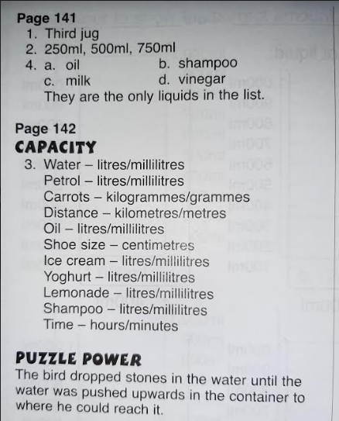
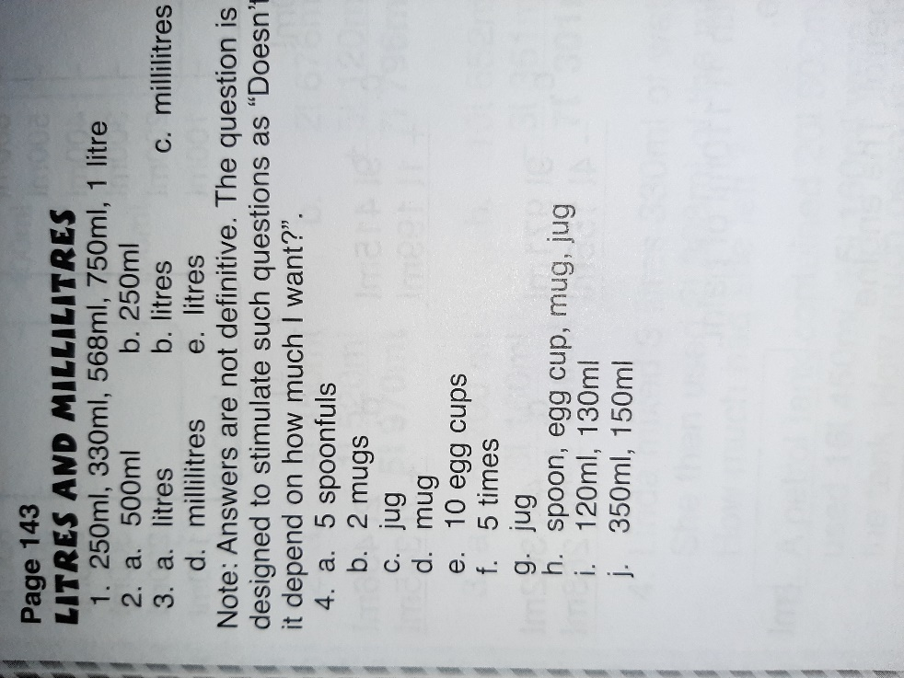
Tables Champion Week 26
