Maths Answers 3rd Class Monday 18th – Friday 22nd May
Maths Time 3 Week 33
Monday | Tuesday | Wednesday | Thursday | Friday
1.50  2.20, 25  3.198, 367, 987  4.5 faces 8 edges  5. Teacher check  6.500  7.180  8.12  9.2.3  10.True  11.517  12.3 r 4  13.1.4, 10.4, 104.1  14.80  15.7 | 1.7 hundreds 4 tens 0 units  2.18  3.3  4.25, 27, 29, 31  5.6  6.700  7. Teacher check  8.1 hr 30 mins  9. 4/8 or 1/2  10.23  11.4 r 4  12.40  13.32  14.<  15.3 in 37.6 | 1.60  2.14  3.€12.45  4.740  5.False  6.700  7.94  8.10  9.4.7  10.No  11.4 r 5  12. 4/8  13.54  14.>  15.8 | 1.869  2.45  3.4  4.€9.20  5.7 m 65 cm  6.394  7.230  8.13  9.110  10.200  11.610  12.3 r 1  13.88  14.33  15.False | 1.4 hundreds 8 tens 1 units  2.60  3.16  4.€3.14  5.128, 198, 629, 657, 689  6.700  7.78  8.11  9.False  10.875  11.749  12.3 r 3  13.80  14.26  15.10

Action Maths – Time
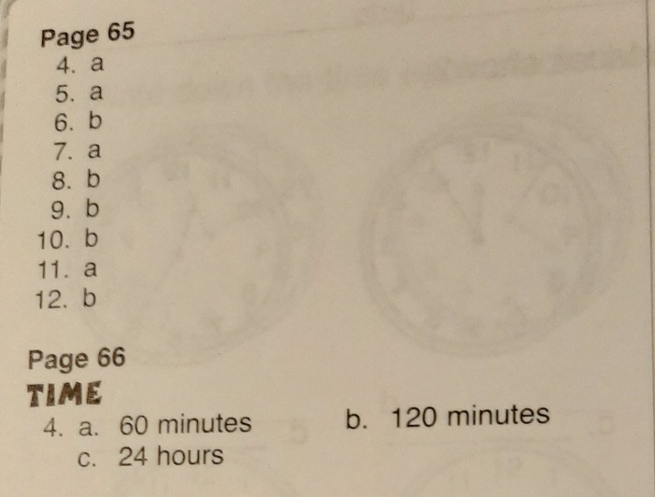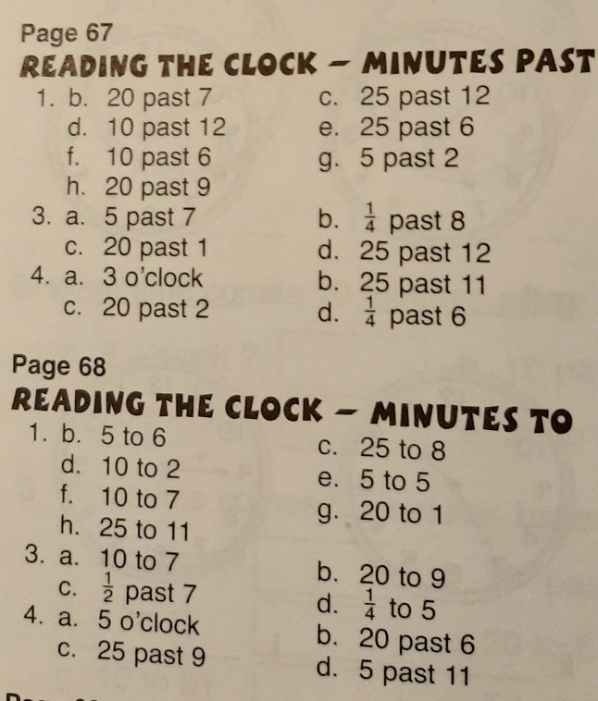

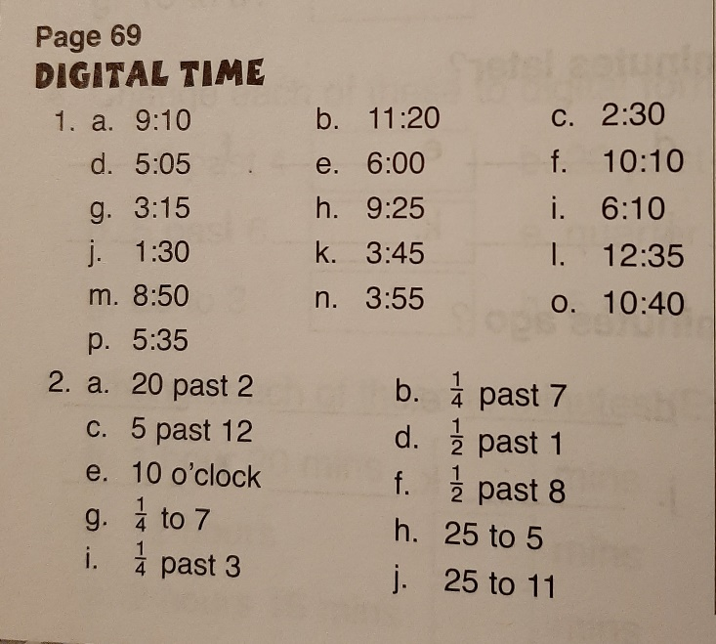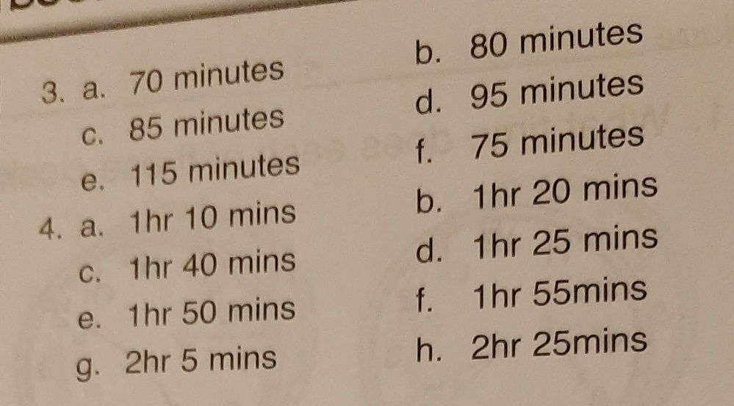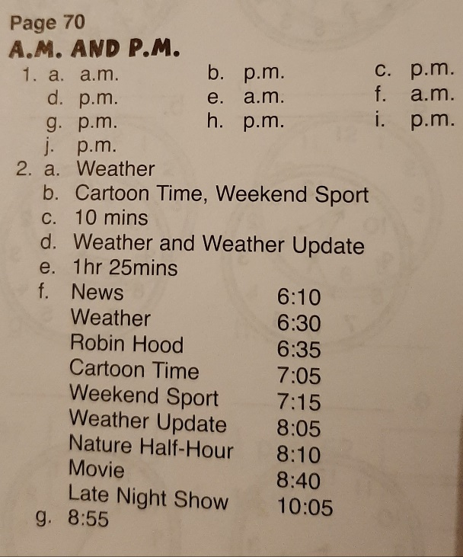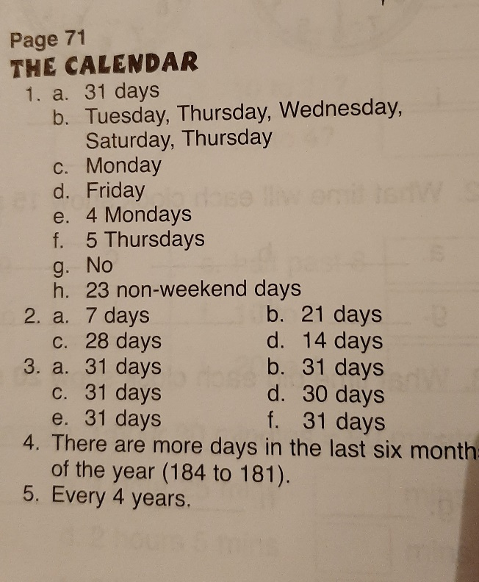

Tables Champion 3 Week 30
