3rd Class Maths Answers Monday 11th – Friday 16th
Maths Time 3 Week 32
Monday | Tuesday | Wednesday | Thursday | Friday
1.4 hundreds 6 tens 5 units  2.12  3.39  4.80  5.6  6.40  7.170  8.34  9. Teacher check  10.1.2  11.5  12.267  13.3 r 2  14.45  15.= | 1.205  2.10  3. Teacher check  4.420, 785, 860  5.35  6.900  7.100  8.10  9.No  10.1.4  11.6 r 3  12. 1/2  13.5.2, 20.5, 50.2  14.4 1/2  15.5 | 1.74  2.320, 567, 867  3.5 corners 8 edges  4.3:10  5.7  6.700  7.180  8.11  9. 5/10 or 1/2  10.856  11.300  12.8 r 3  13.31  14.>  15.3 1/2 | 1.629  2.10  3.20  4.5  5.€8.92  6.5  7.135  8.18 r 2  9. 6/8 or 3/4  10.300  11.7 r 1  12.20  13.8  14.8  15.< | 1.370  2.80  3.14  4.189, 275, 298  5.350  6.300  7.500  8.198  9.7  10.1.8  11.560  12.9 r 4  13.17  14.4  15. 7/8 6/10 1/2

Action Maths : Area
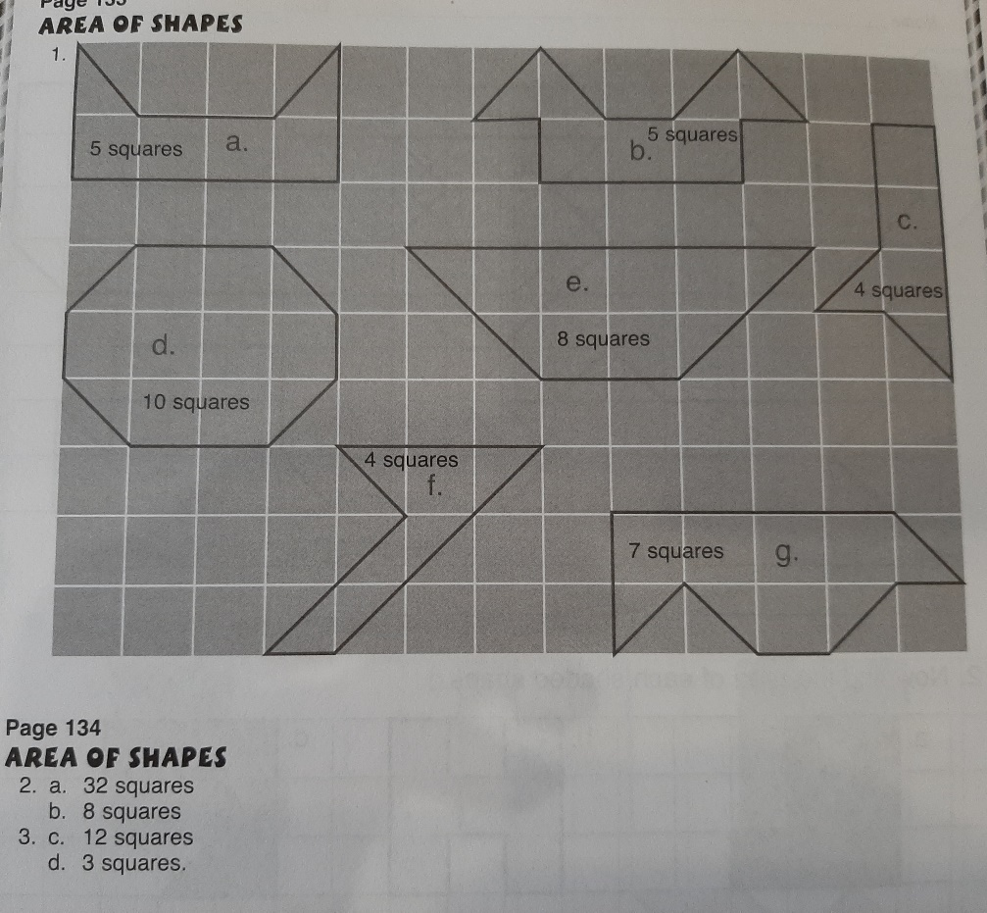
Calculate the Area worksheet
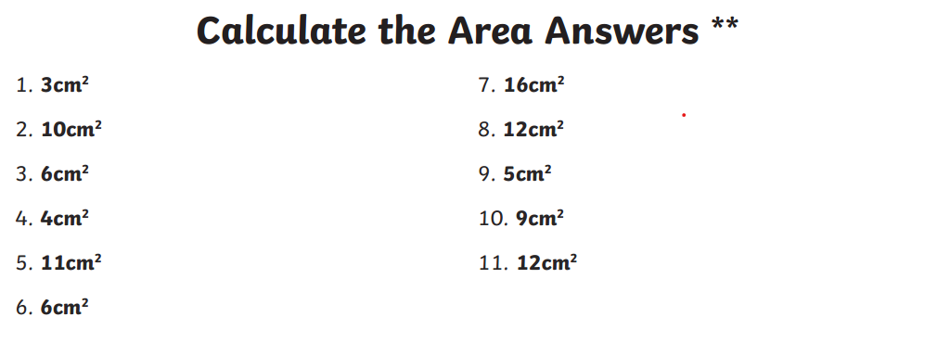
Tables Champion Week 29
